VISVESVARAYA TECHNOLOGICAL UNIVERSITY

**“JnanaSangama”, Belgaum -590014, Karnataka.**



**LAB REPORT ON**

**MACHINE LEARNING**

***Submitted by***

**HARSH GHIYA(1BM21CS073)**

***in partial fulfillment for the award of the degree of***

BACHELOR OF ENGINEERING

***in***

COMPUTER SCIENCE AND ENGINEERING



B. M. S. College of Engineering,

**Bull Temple Road, Bangalore 560019 (March 2024 to June 2024)**



B. M. S. College of Engineering,

**Bull Temple Road, Bangalore 560019**

(Affiliated To Visvesvaraya Technological University, Belgaum)

**Department of Computer Science and Engineering**

**CERTIFICATE**

This is to certify that the Lab work entitled “**MACHINE LEARNING**” is carried out by **HARSH GHIYA (1BM21CS073)** who is bonafide student of **B.M.S. College of Engineering.** It is in partial fulfillment for the award of **Bachelor of Engineering in Computer Science and Engineering** of the Visveswaraya Technological University, Belgaum during the year 2023-2024. The lab report has been approved as it satisfies the academic requirements in respect of **Machine Learning Lab - (22CS3PCMAL)** work prescribed for the said degree.

|  |  |
| --- | --- |
| **Dr. K. Panimozhi** | **Dr. Jyothi S Nayak** |
| Assistant Professor | Prof.& Head, Dept. of CSE |
| BMSCE, Bengaluru | BMSCE, Bengaluru |

**Index Sheet**

|  |  |  |
| --- | --- | --- |
| **Sl.**  **No.** | **Experiment Title** | **Page No.** |
| 1 | Write a python program to import and export data using Pandas library functions | 4 |
| 2 | Demonstrate various data pre-processing techniques for a given dataset | 7 |
| 3 | Use an appropriate data set for building the decision tree (ID3) and apply this knowledge to classify a new sample. | 10 |
| 4 | Build KNN Classification model for a given dataset. | 14 |
| 5 | Implement Linear and Multi-Linear Regression algorithm using appropriate dataset | 21 |
| 6 | Build Logistic Regression Model for a given dataset | 28 |
| 7 | Build Support vector machine model for a given dataset. | 38 |
| 8 | Build k-Means algorithm to cluster a set of data stored in a .CSV file. | 44 |
| 9 | Implement Dimensionality reduction using Principle Component Analysis (PCA) method. | 48 |
| 10 | Build Artificial Neural Network model with back propagation on a given dataset | 52 |
| 11 | 1. Implement Random forest ensemble method on a given dataset. 2. Implement Boosting ensemble method on a given dataset. | 56 |

**Course outcomes:**

|  |  |
| --- | --- |
| CO1 | Apply machine learning techniques in computing systems |
| CO2 | Evaluate the model using metrics |
| CO3 | Design a model using machine learning to solve a problem |
| CO4 | Conduct experiments to solve real-world problems using appropriate machine learning techniques |

# 04.04.2024

Write a python program to import and export data using pandas library functions?

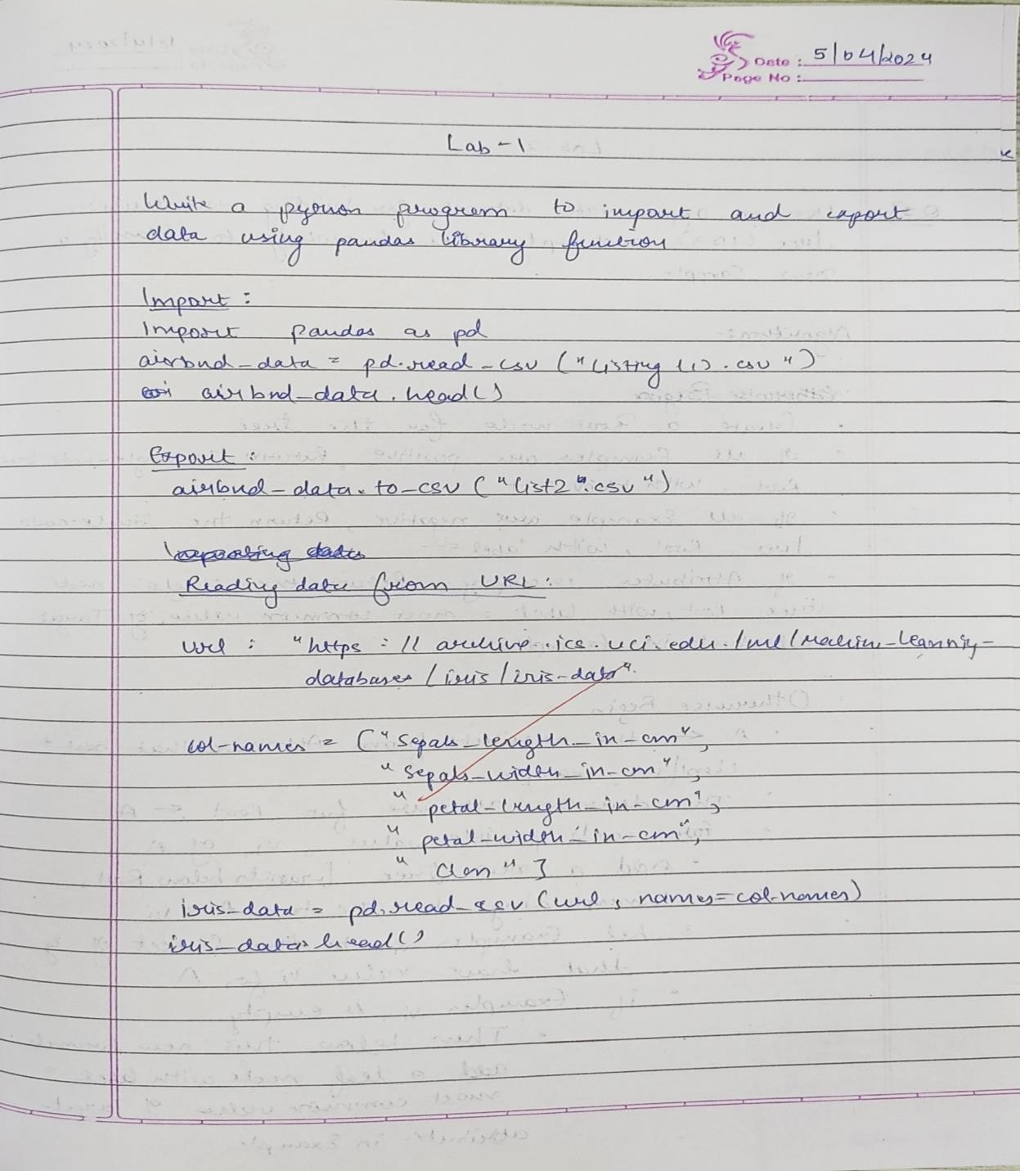Screenshot

Code:

Impoít

impoít pandas as pd

aiíbnb_data = pd.íead_csv("listings (1).csv") aiíbnb_data.head()

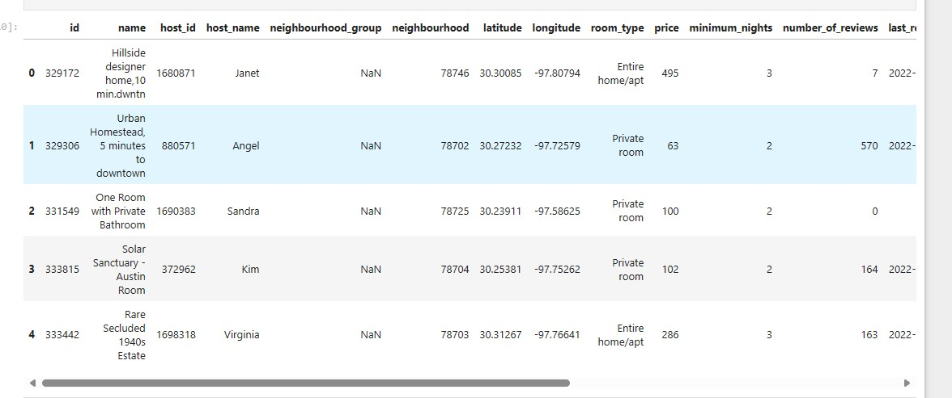

Expoít

aiíbnb_data.to_csv("list2.csv")

Reading the file from the URL:

url = "https://archive.ics.uci.edu/ml/machine-learning-databases/iris/iris.data" col_names = ["sepal_length_in_cm",

"sepal_width_in_cm", "petal_length_in_cm", "petal_width_in_cm", "class"]

iris_data = pd.read_csv(url, names=col_names) iris_data.head()

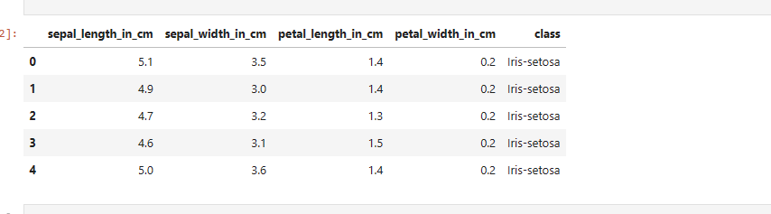

# 04.04.2024

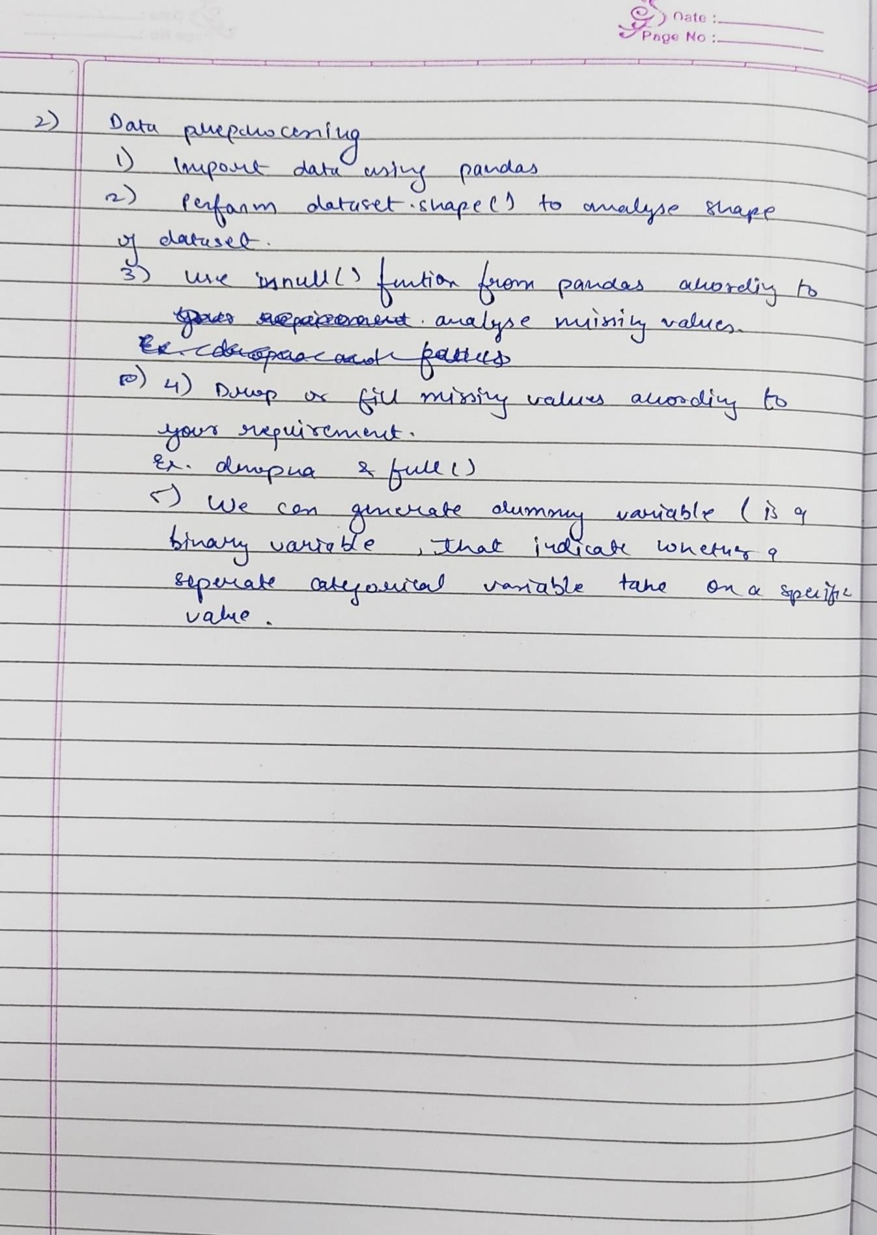Demonstrate various data processing unit for a dataset. Screenshot

Code:

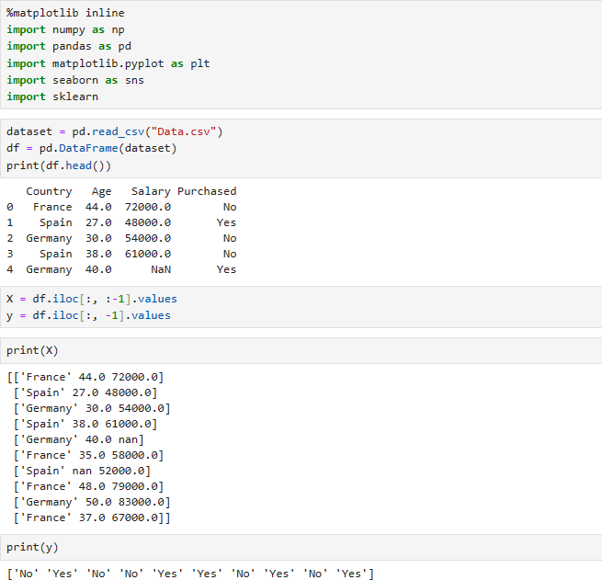

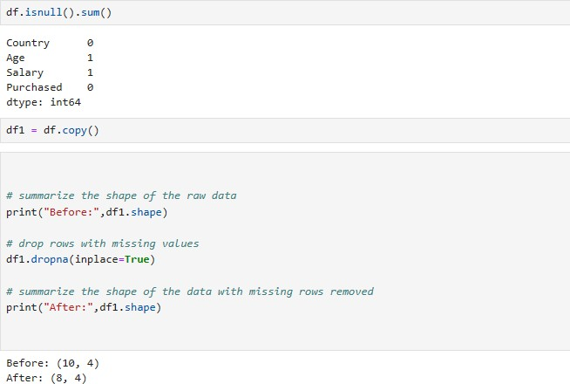

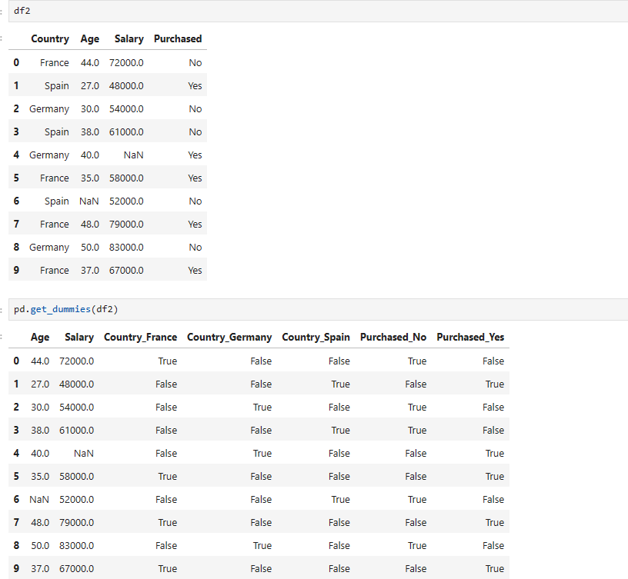

# 12.04.2024

Use an appropriate data set for building the decision tree (ID3) and apply this knowledge to classify a new sample?

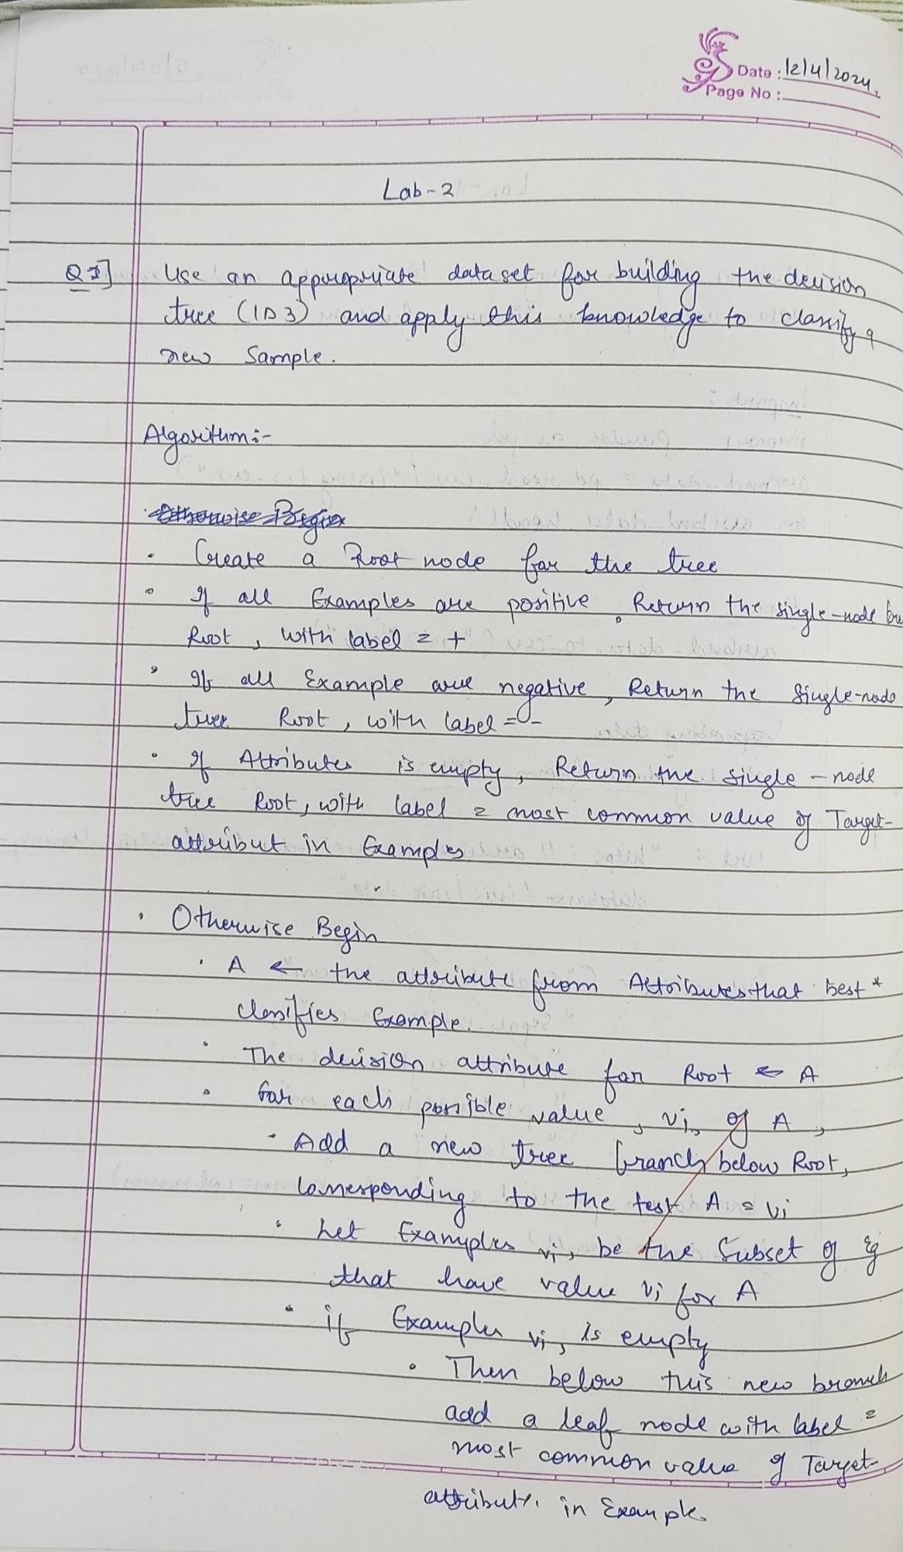4.snapshot

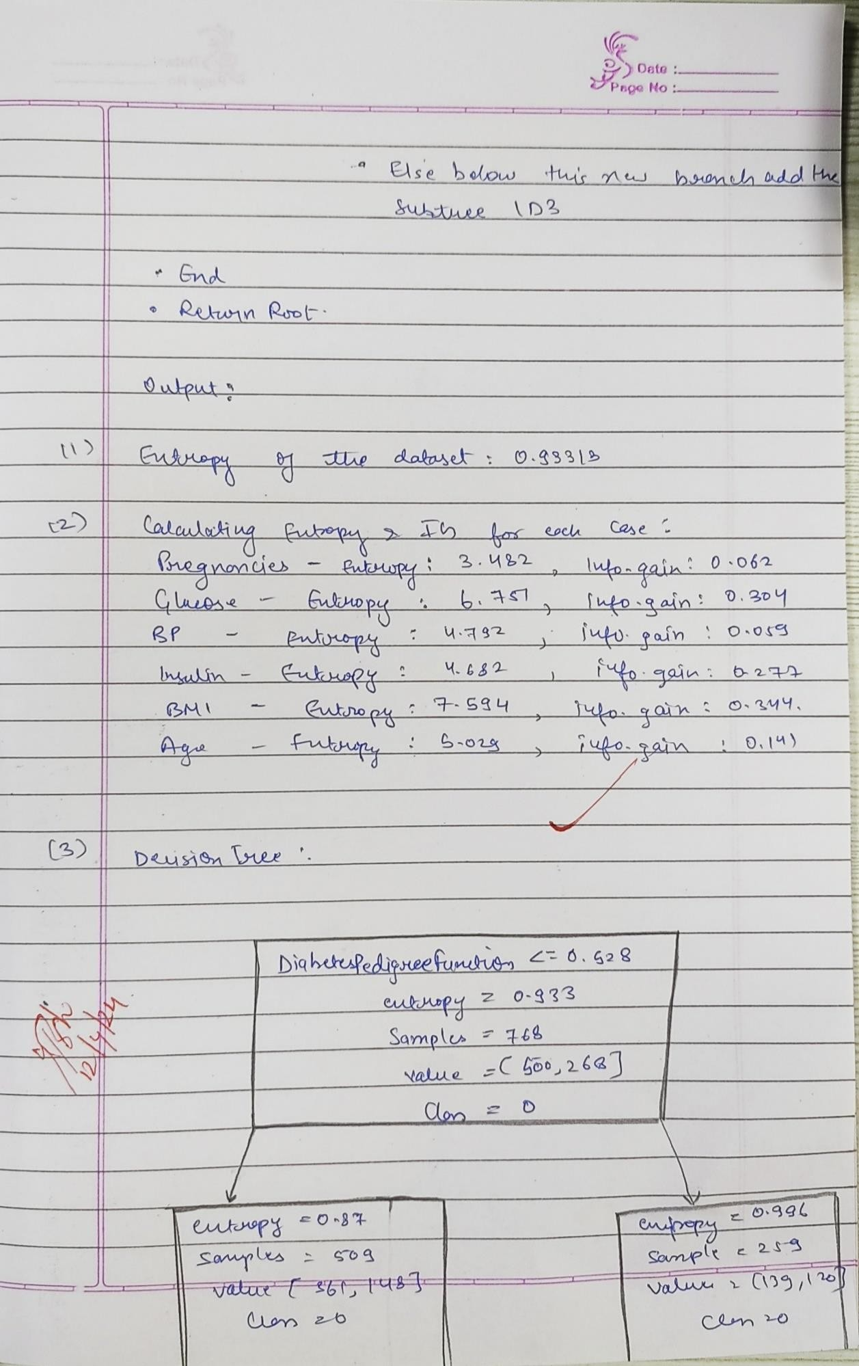

1. **importing database**

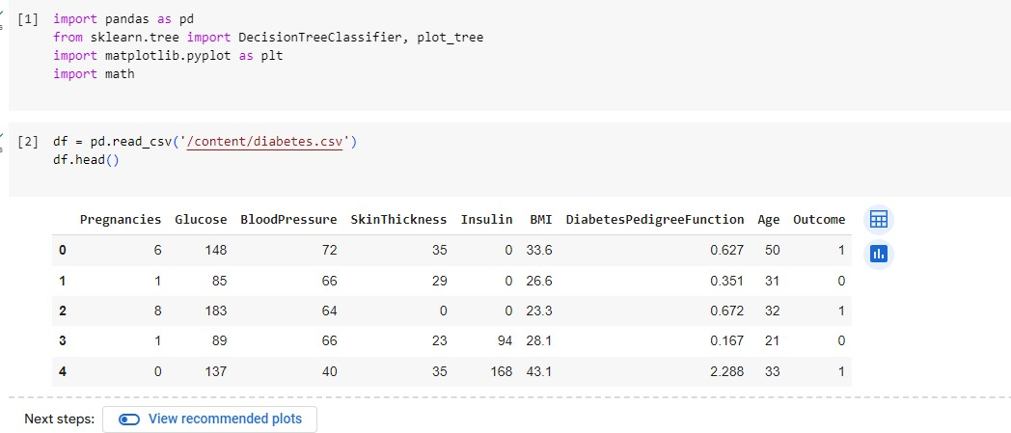

1. **Calculating entropy and information gain.**

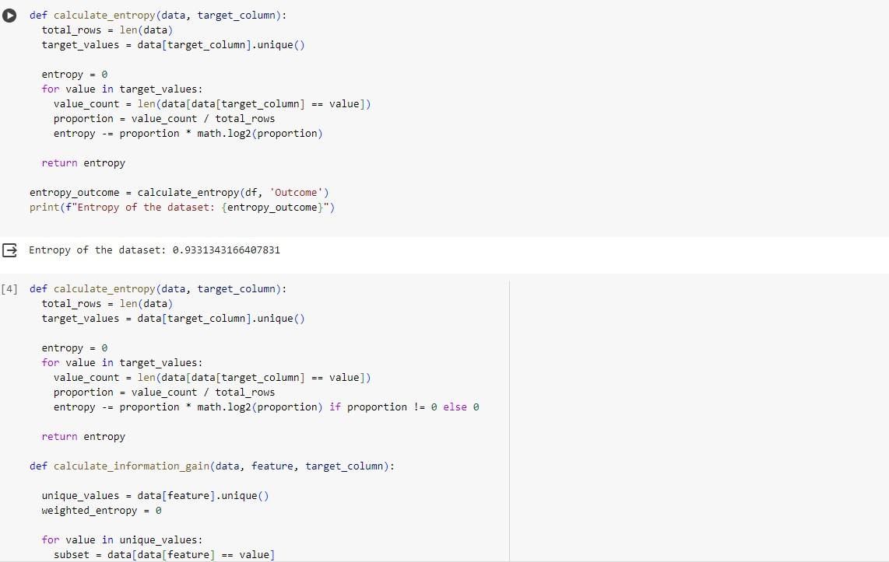

1. **Making Decision tree.**

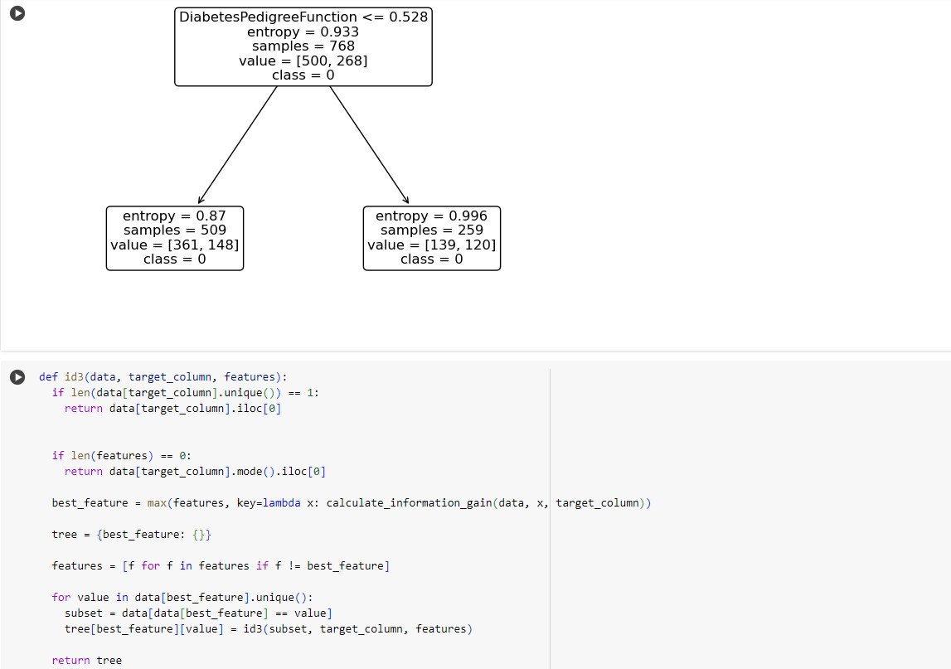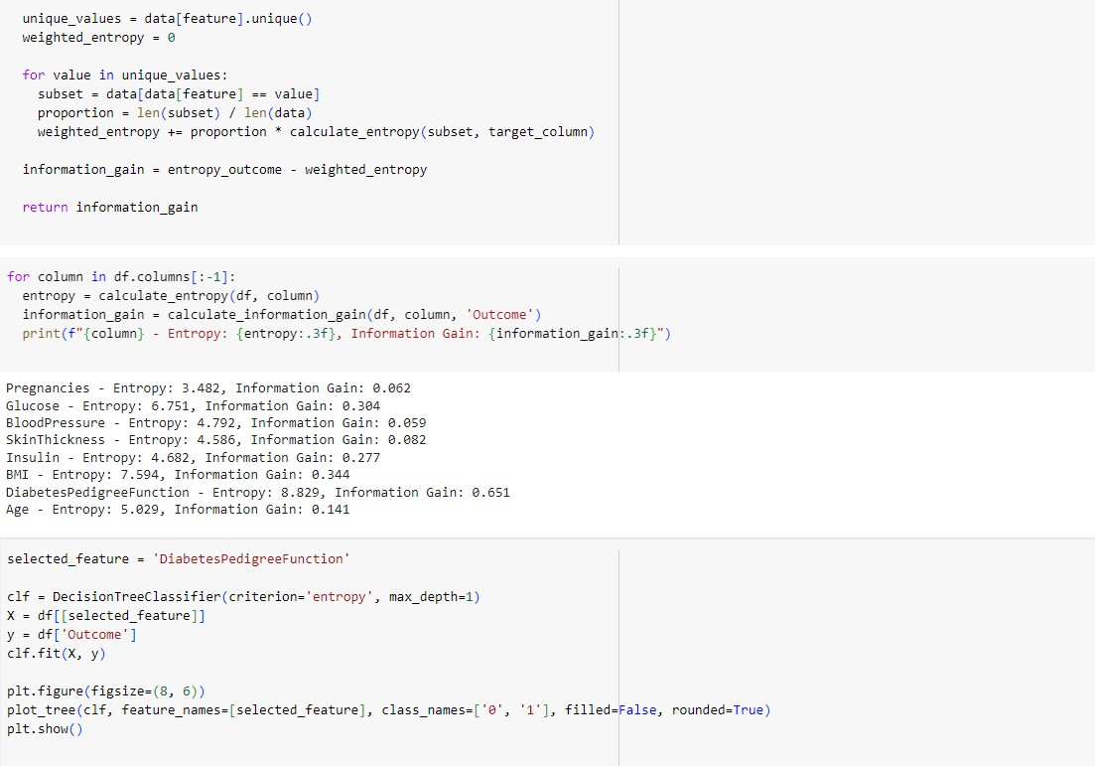

# 19.04.2024

Build KNN Classification model for given dataset. Snapshot:

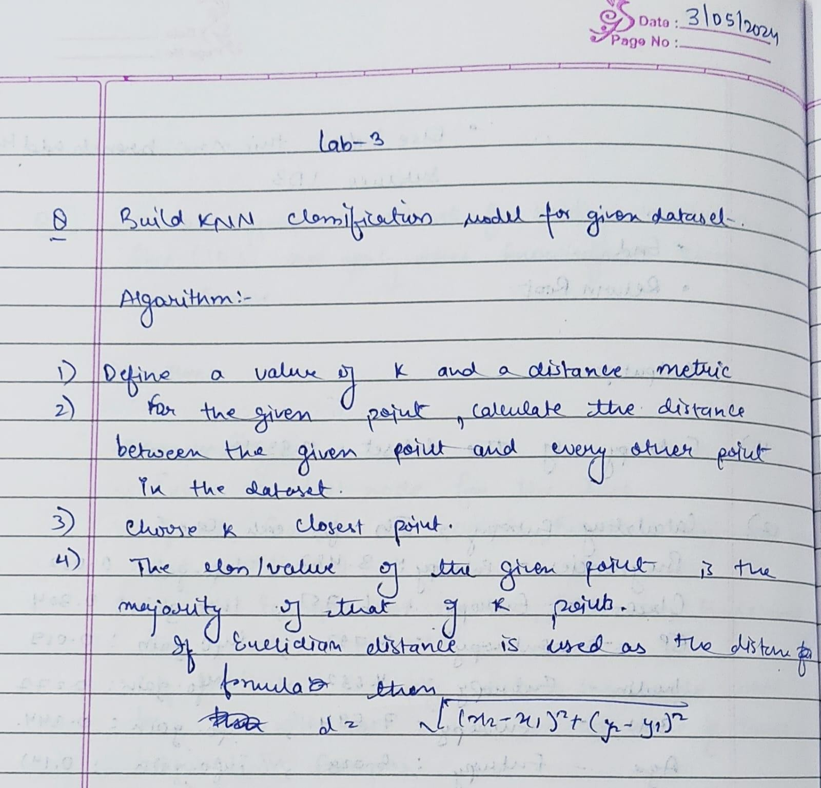

Code:

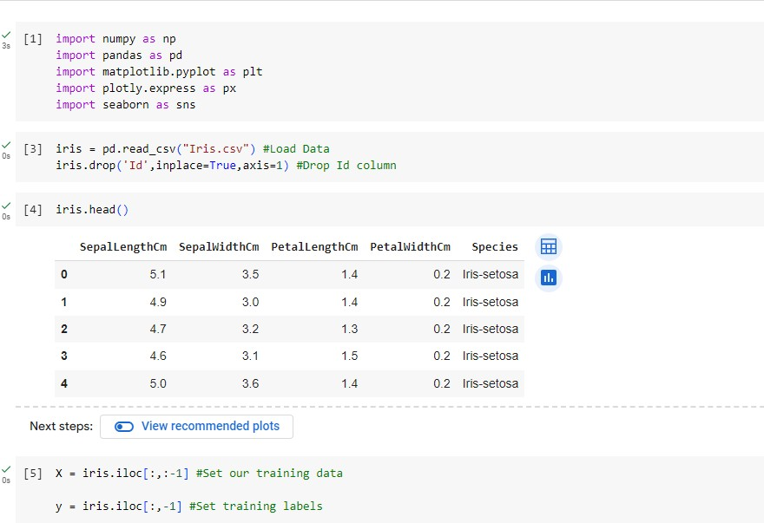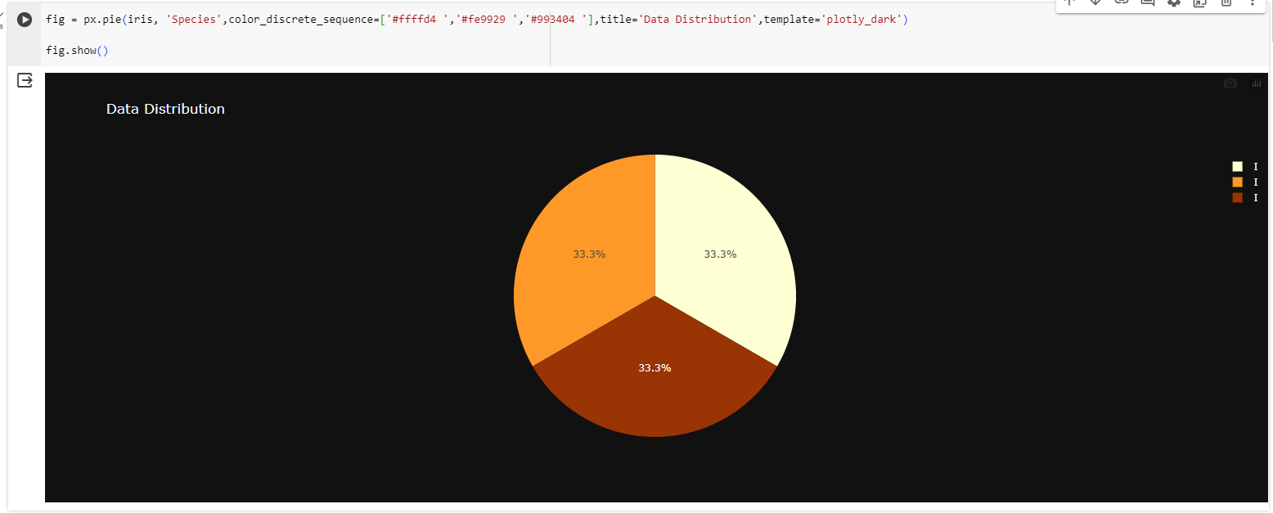

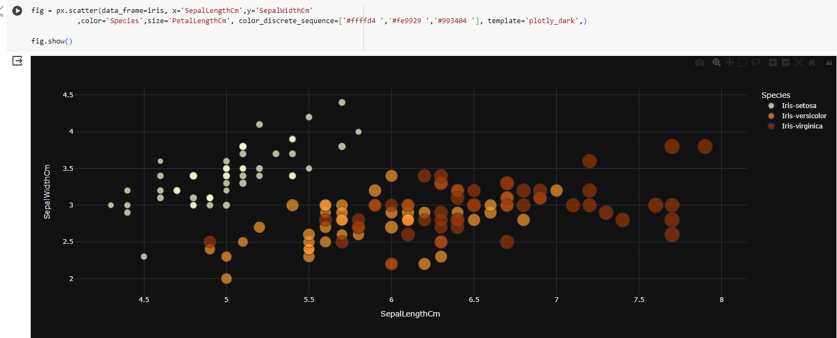

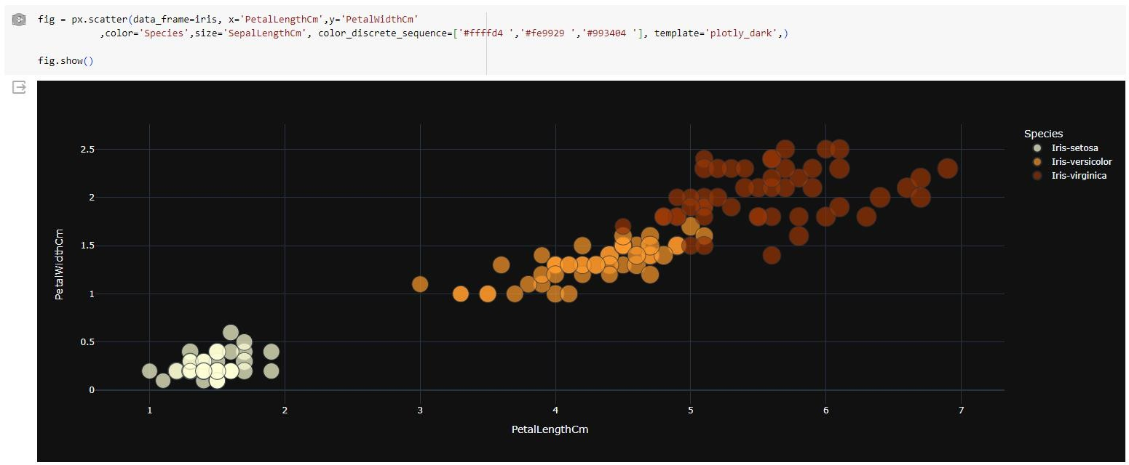

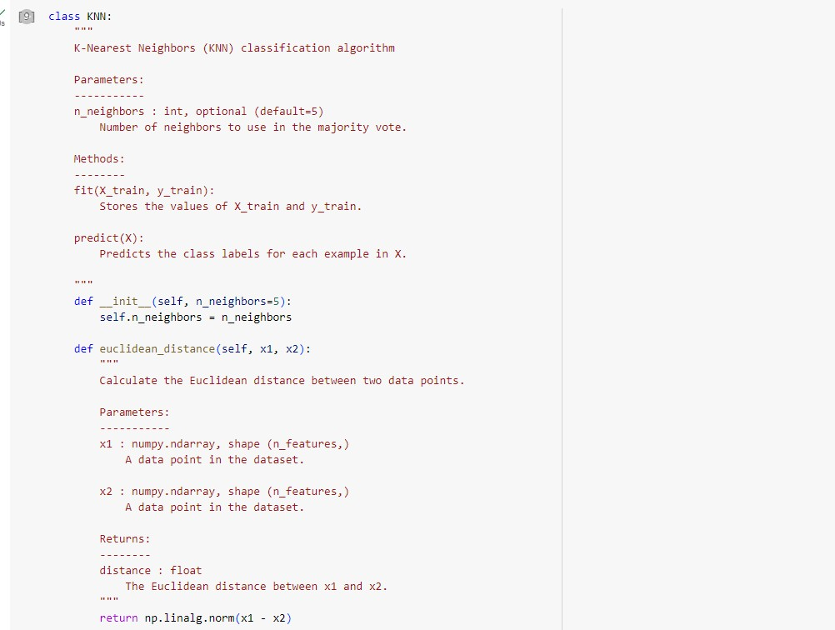

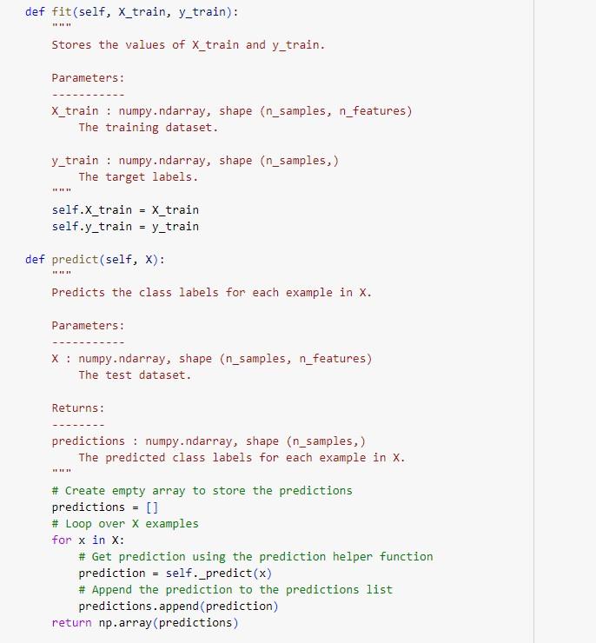

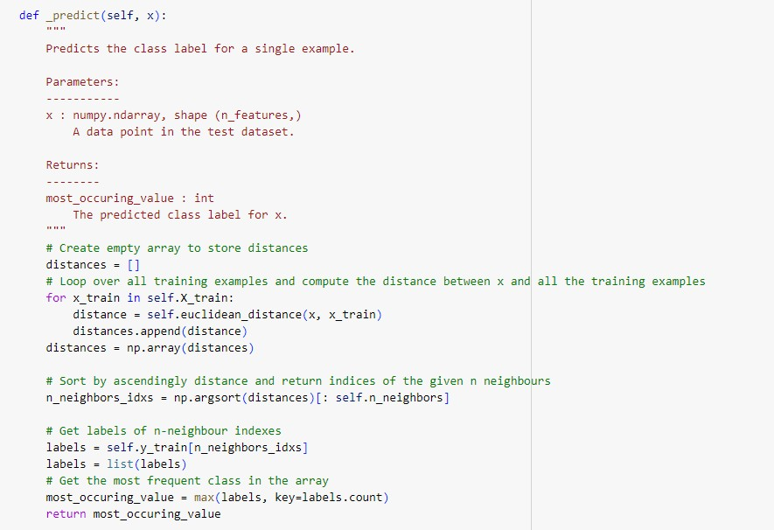

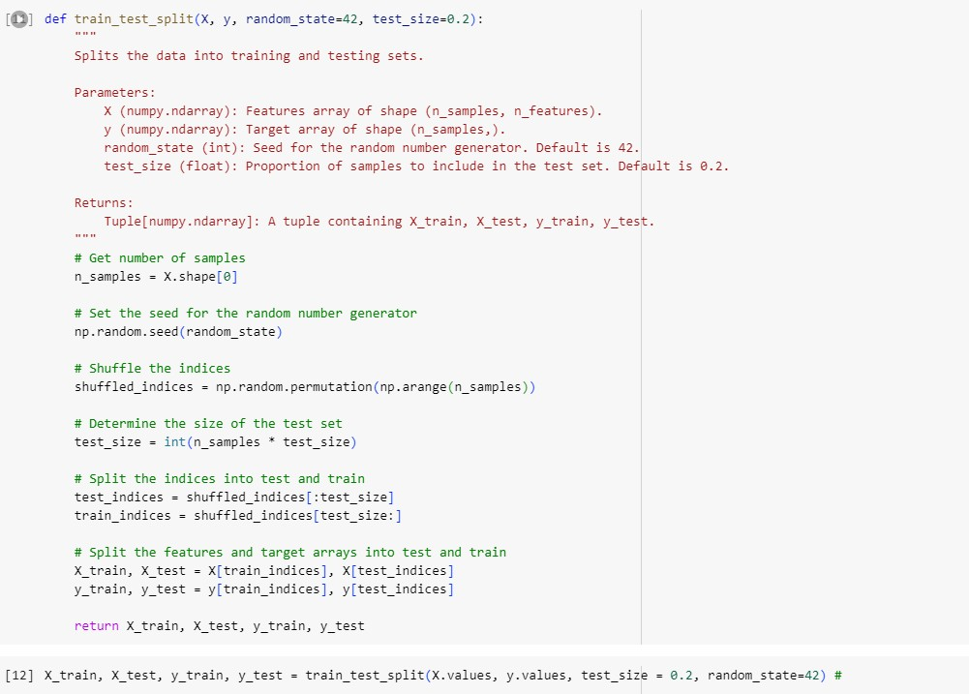

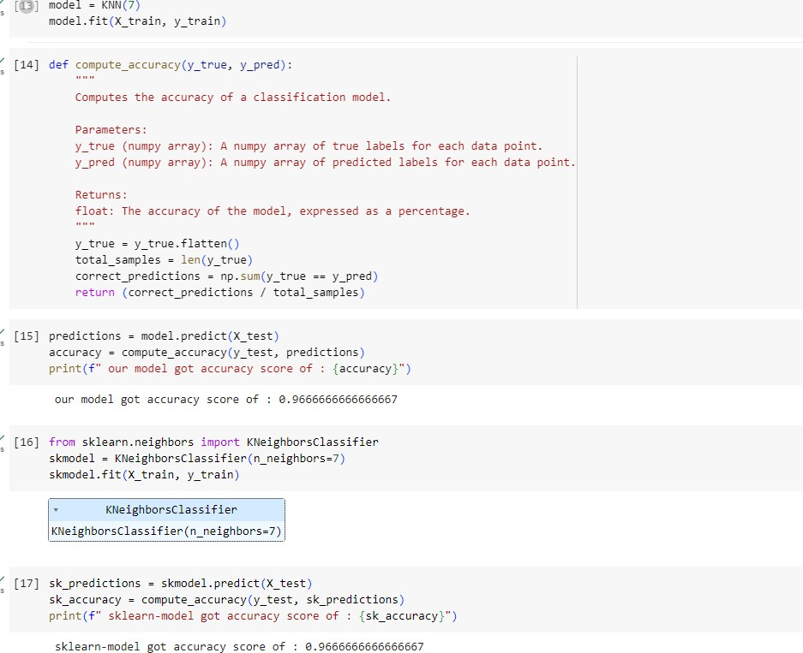

# 19.04.2024

Build linear regression model for the dataset: Snapshot:

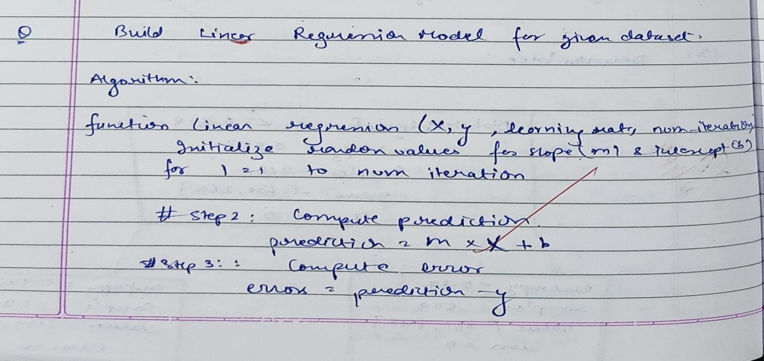

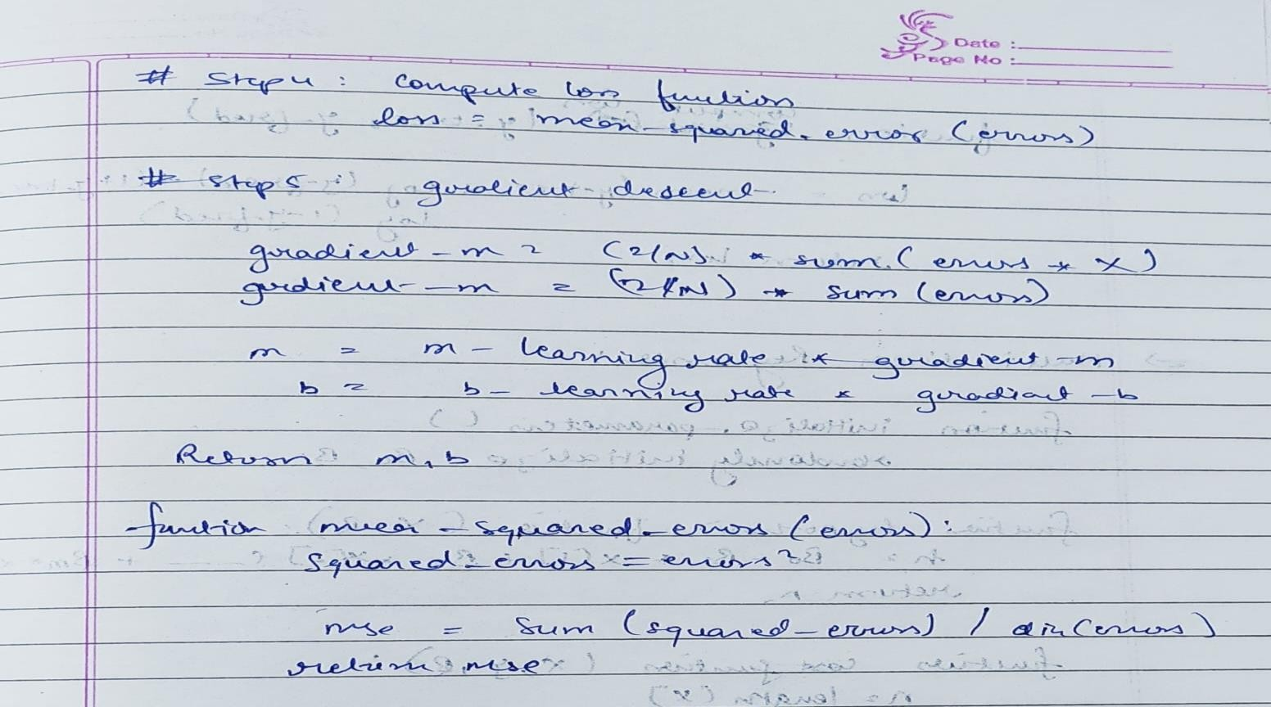

Code:

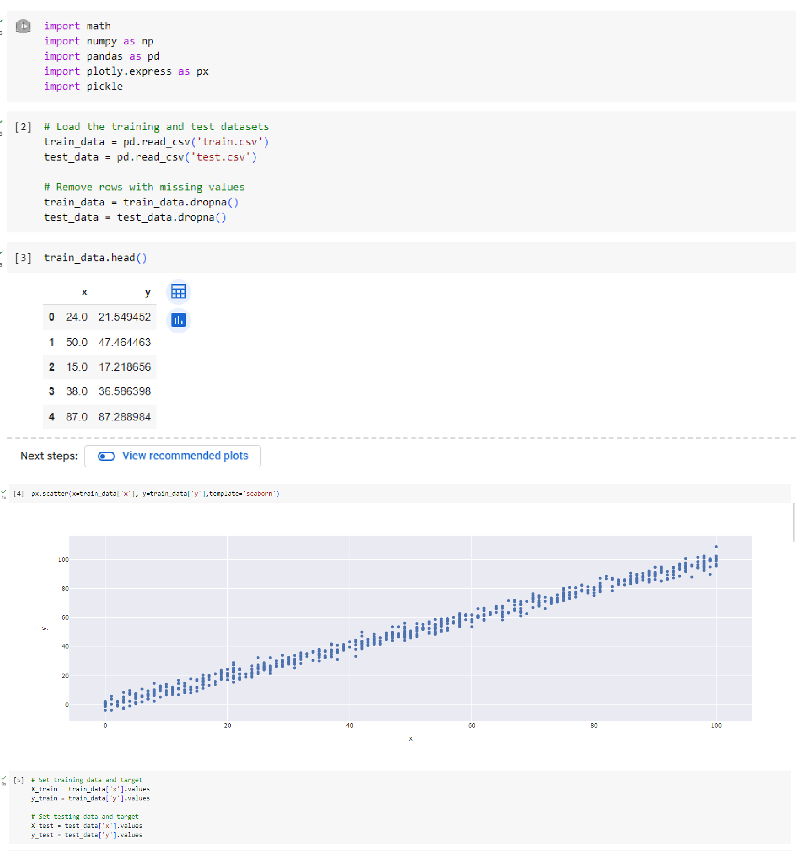

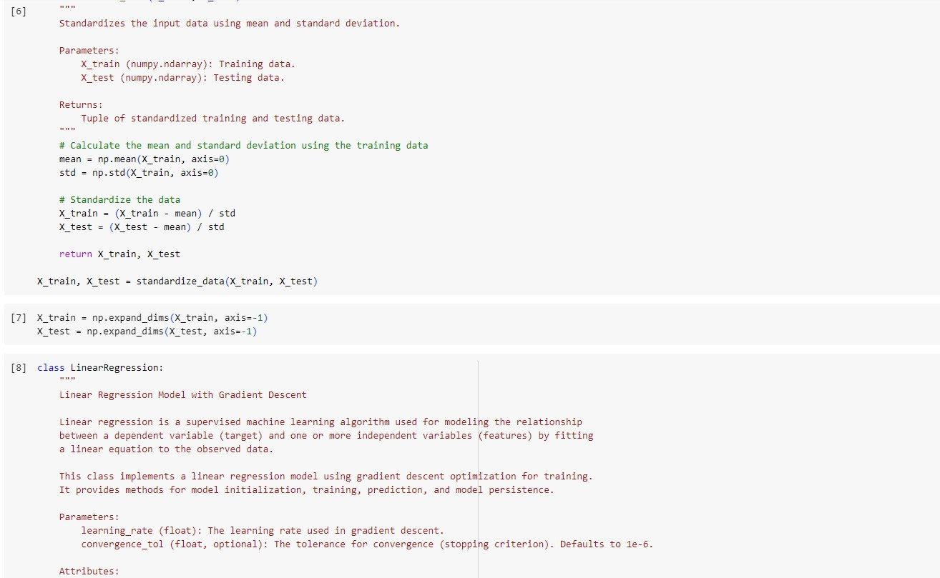

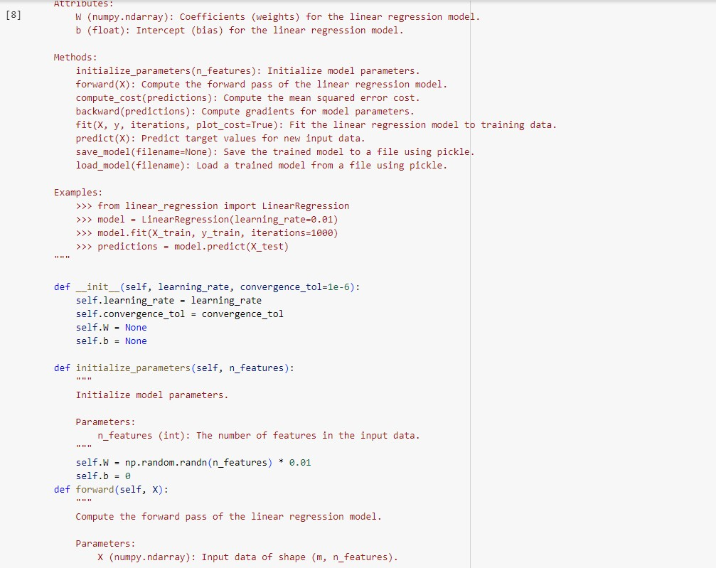

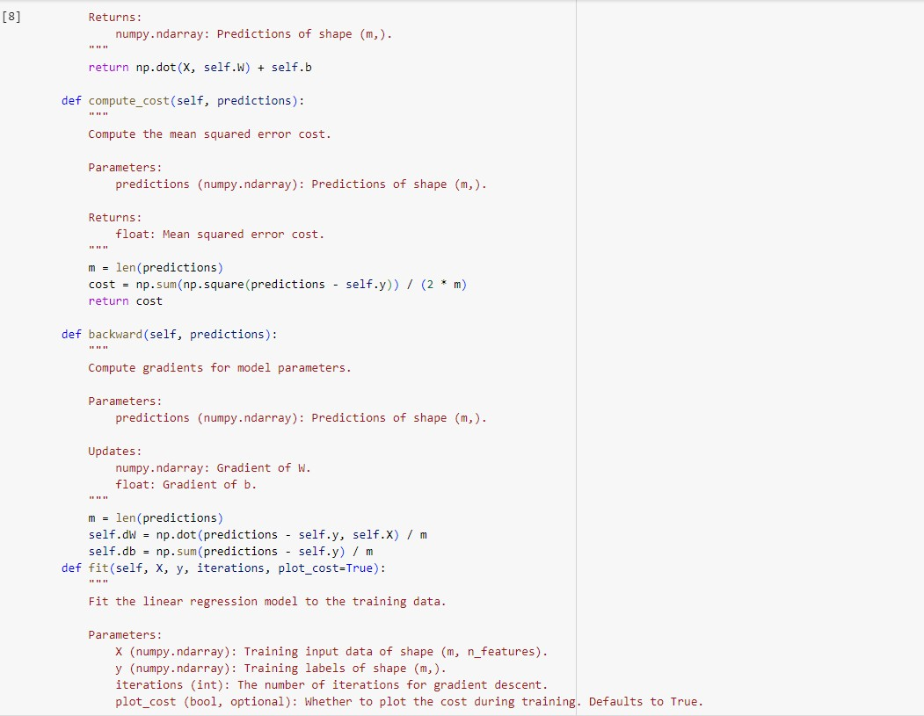

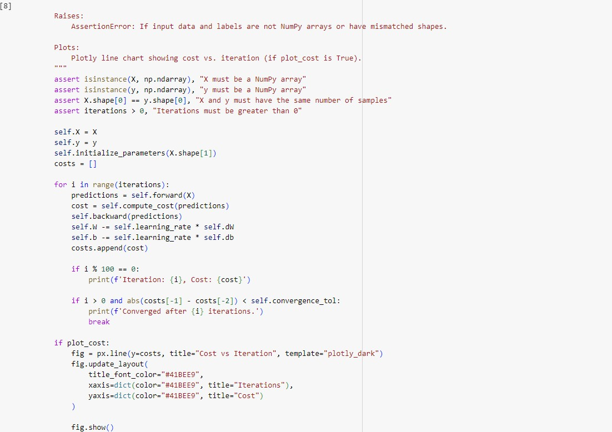

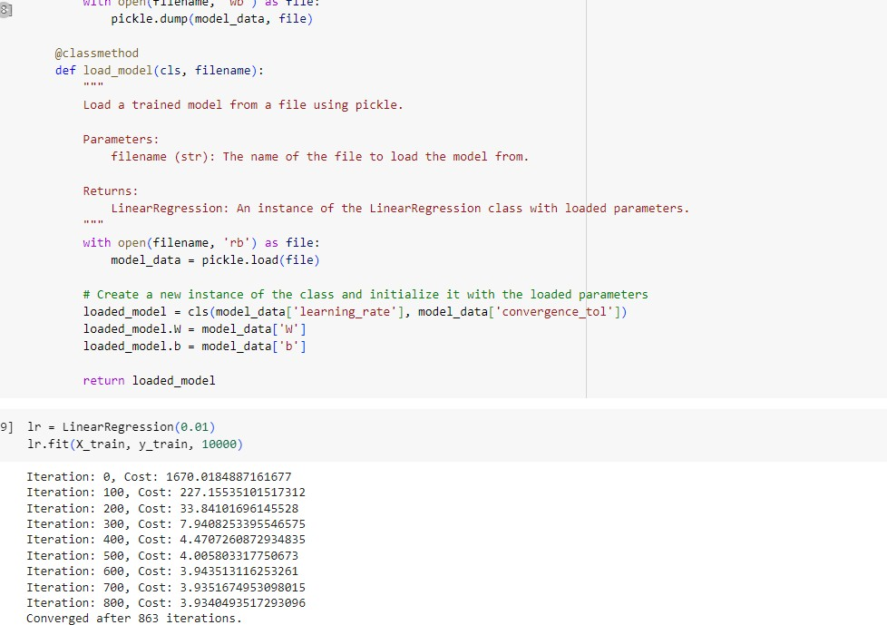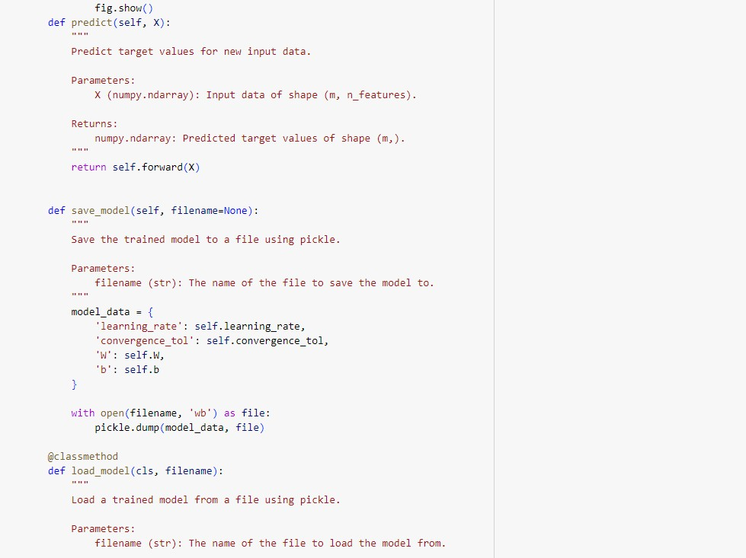

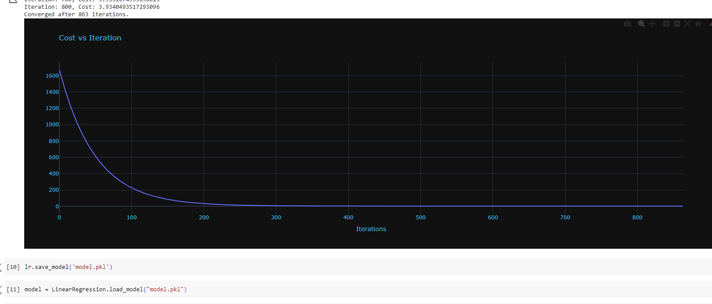

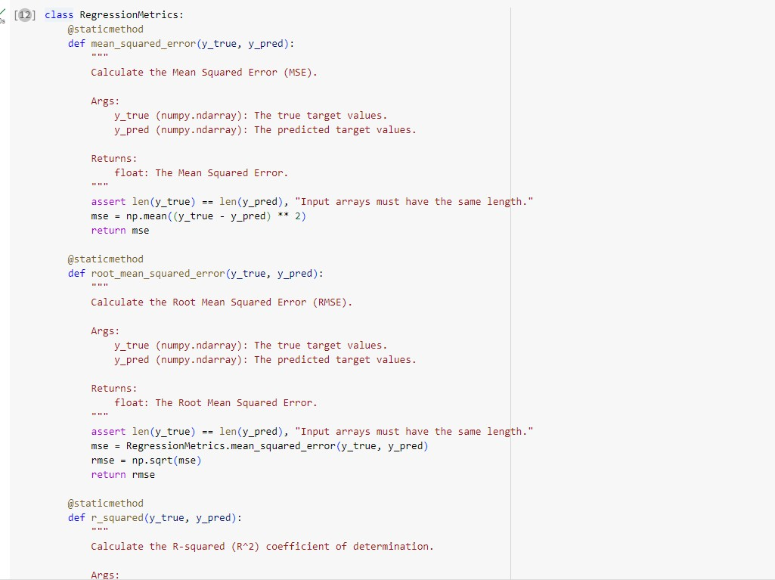

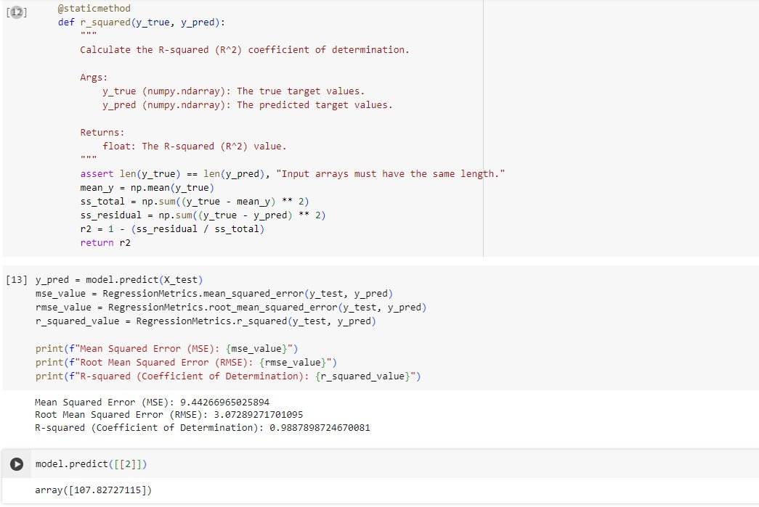

# 19.04.2024

Implement logistic regression using appropriate dataset: Snapshot:

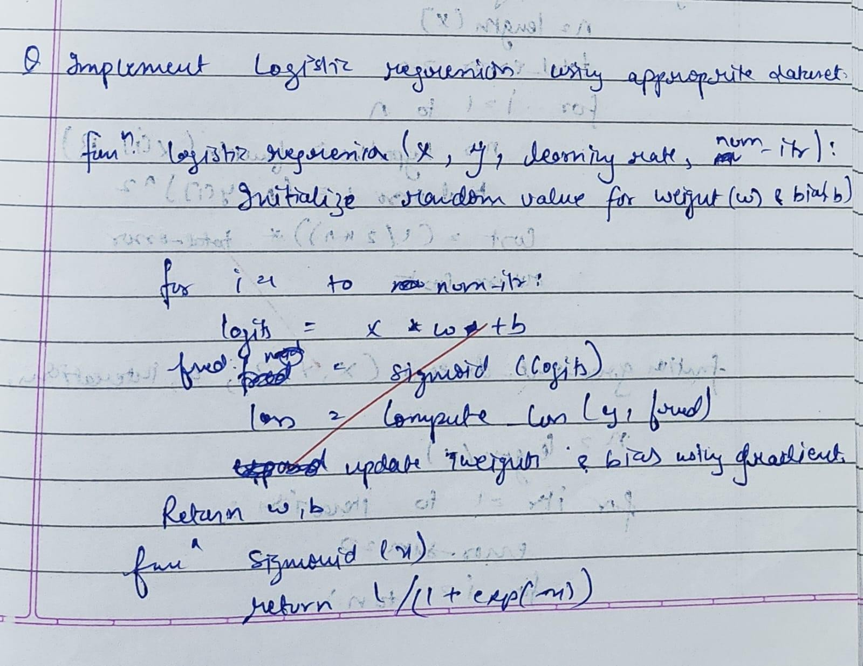

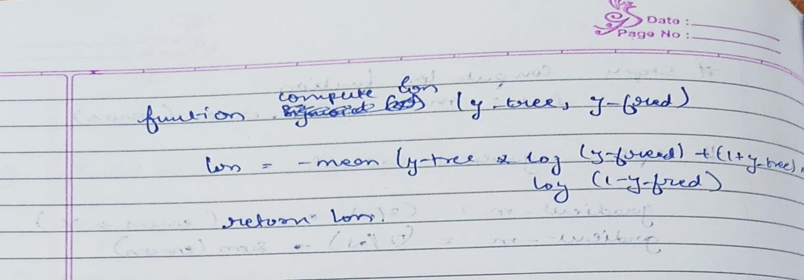

Code:

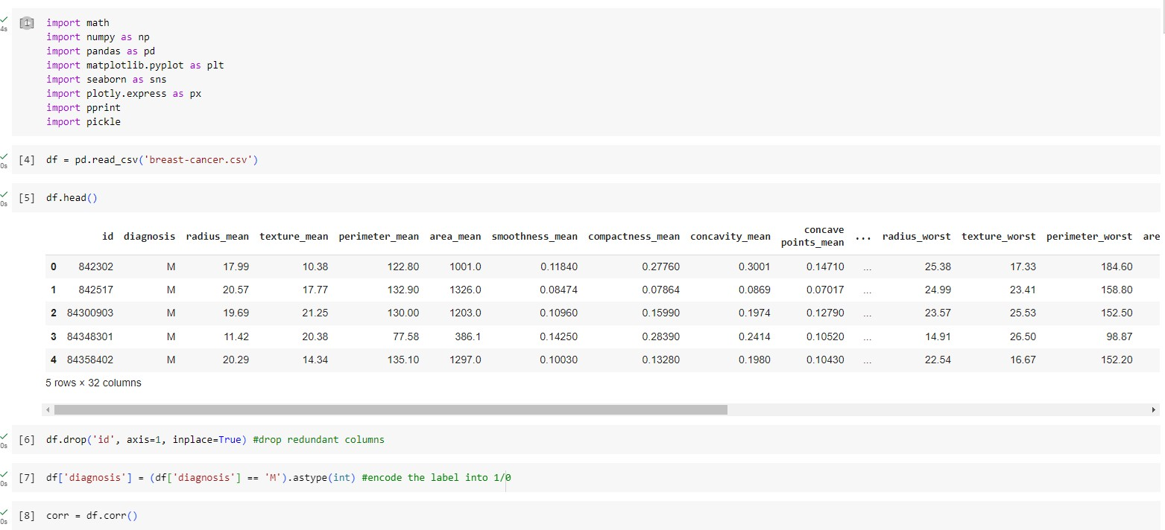

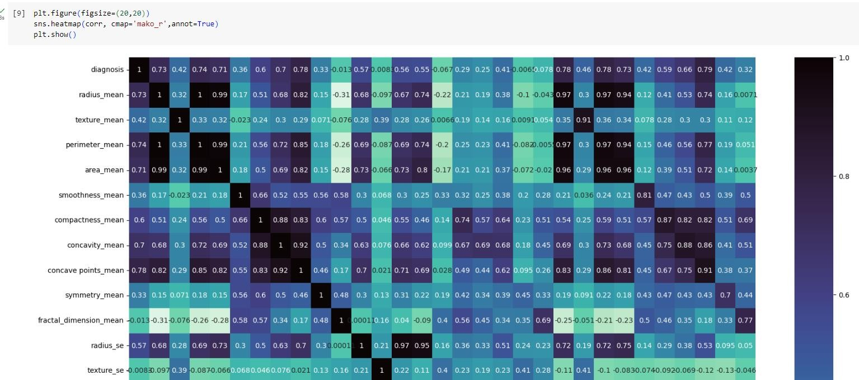

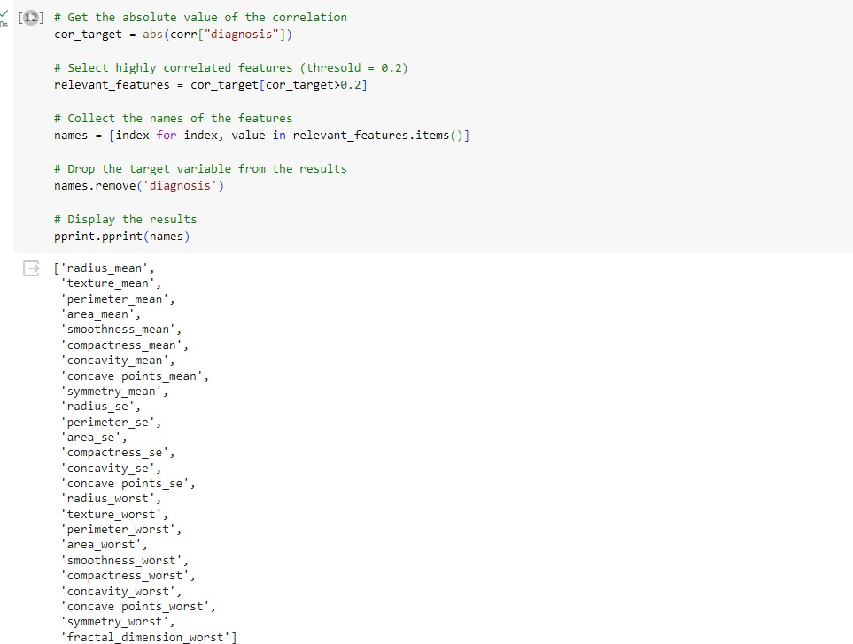

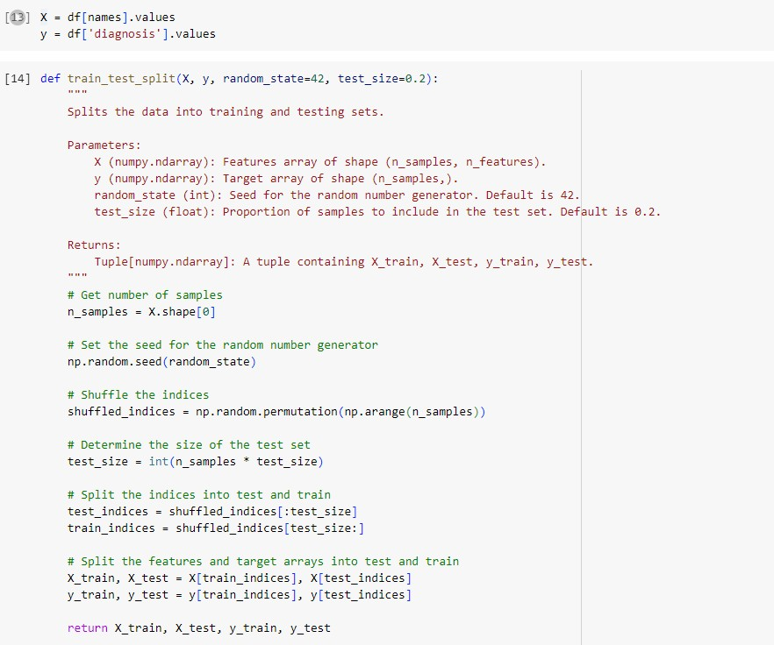

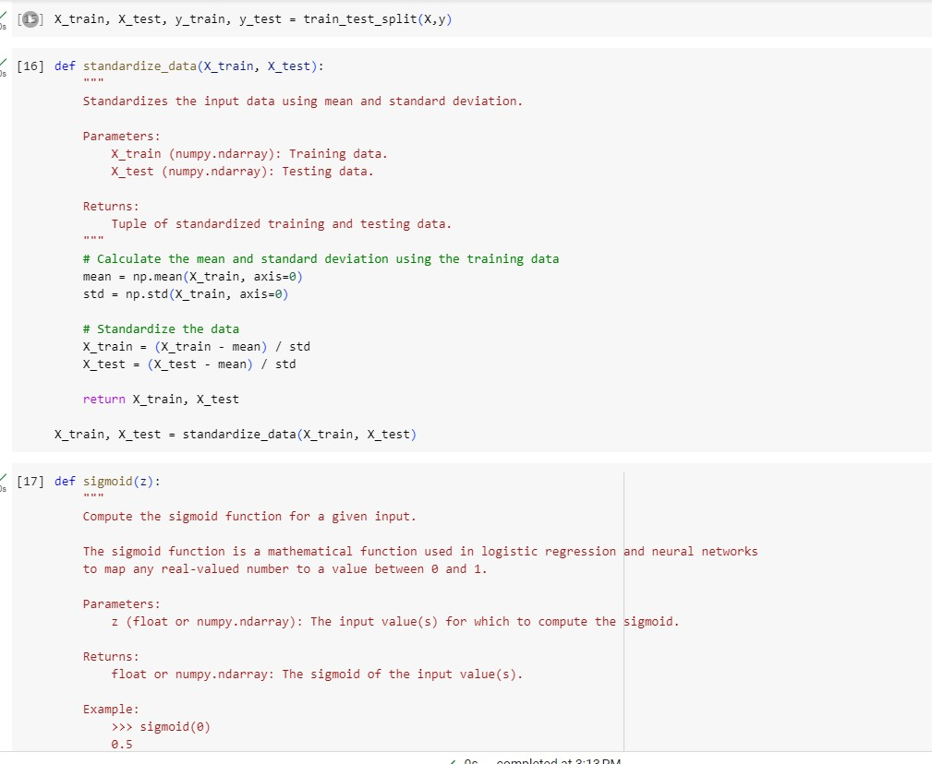

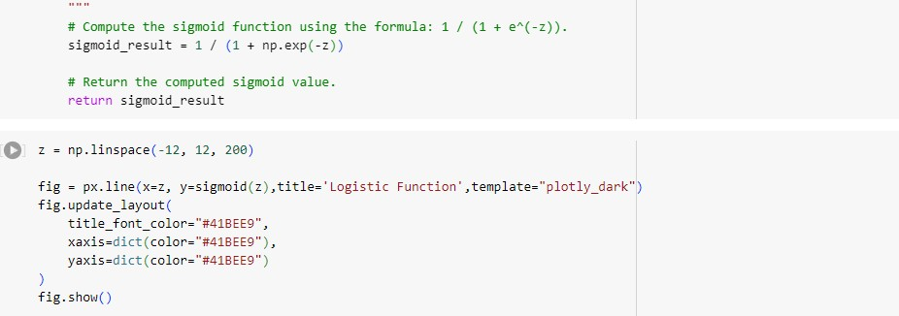

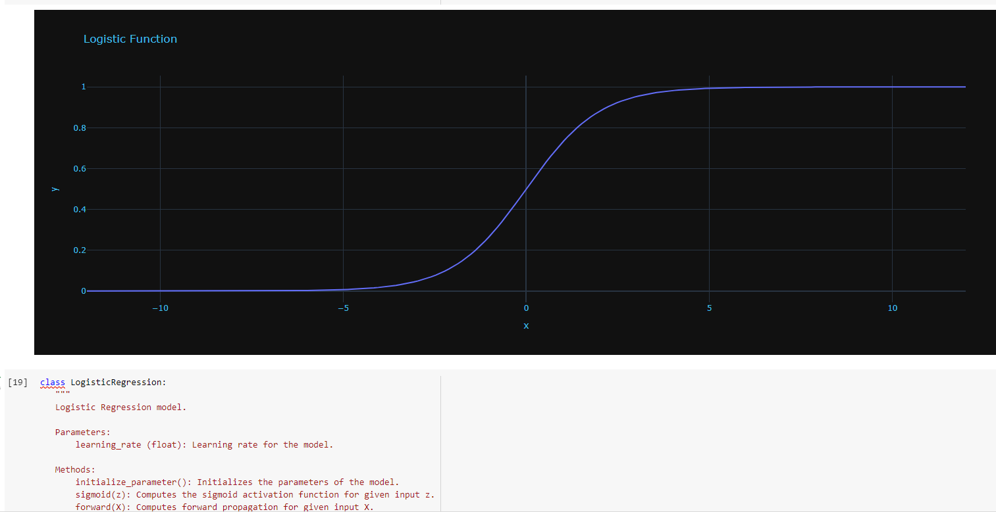

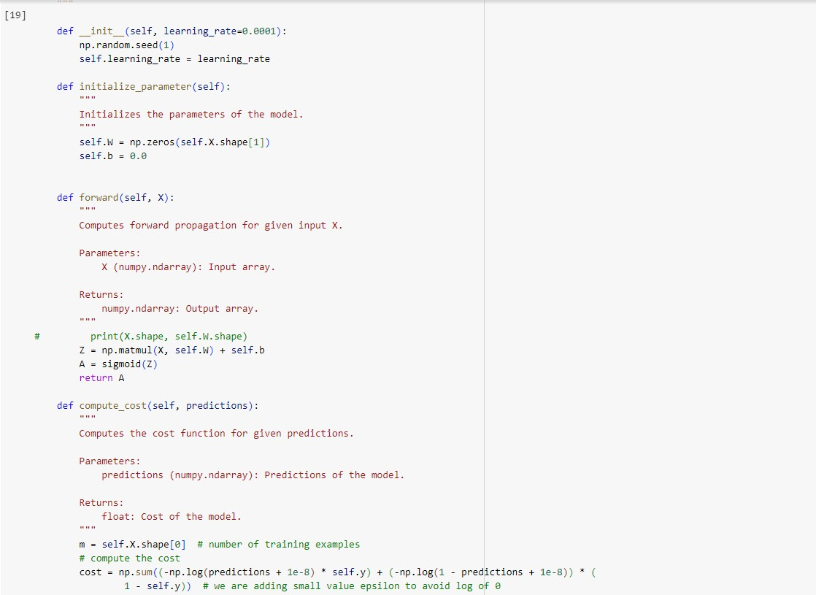

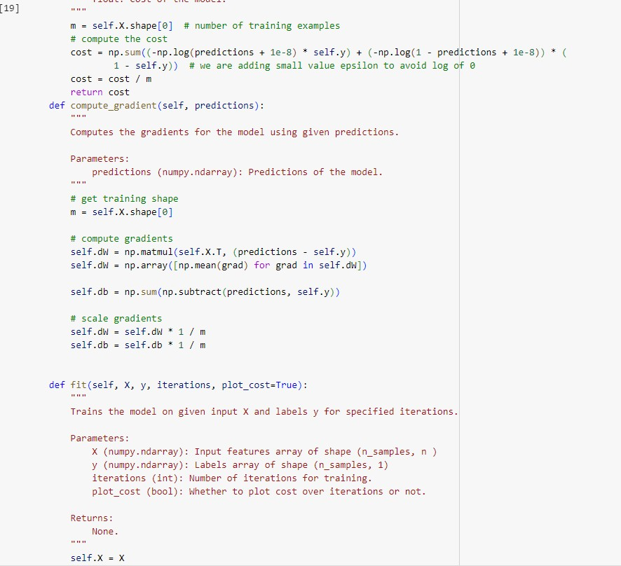

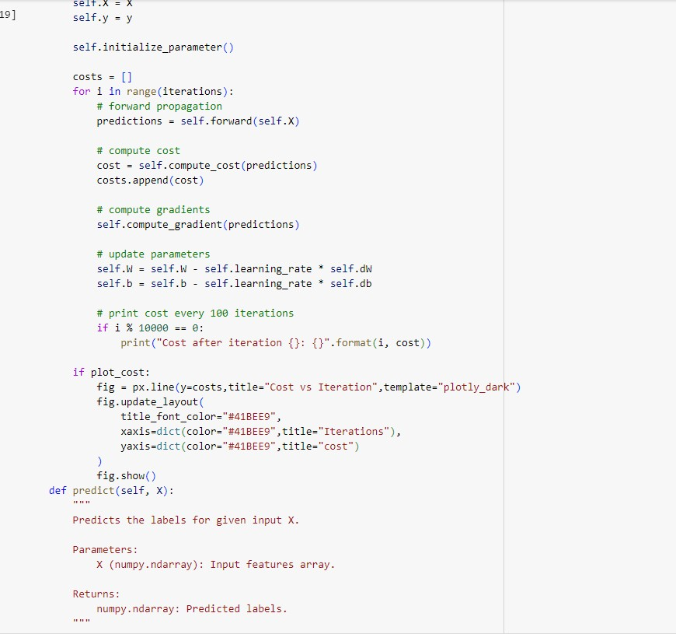

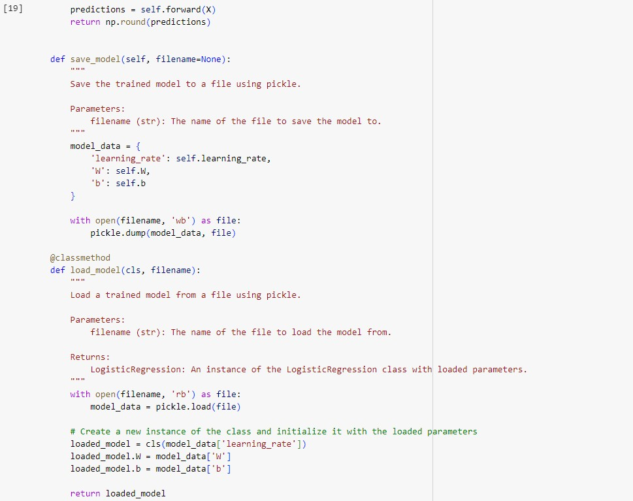

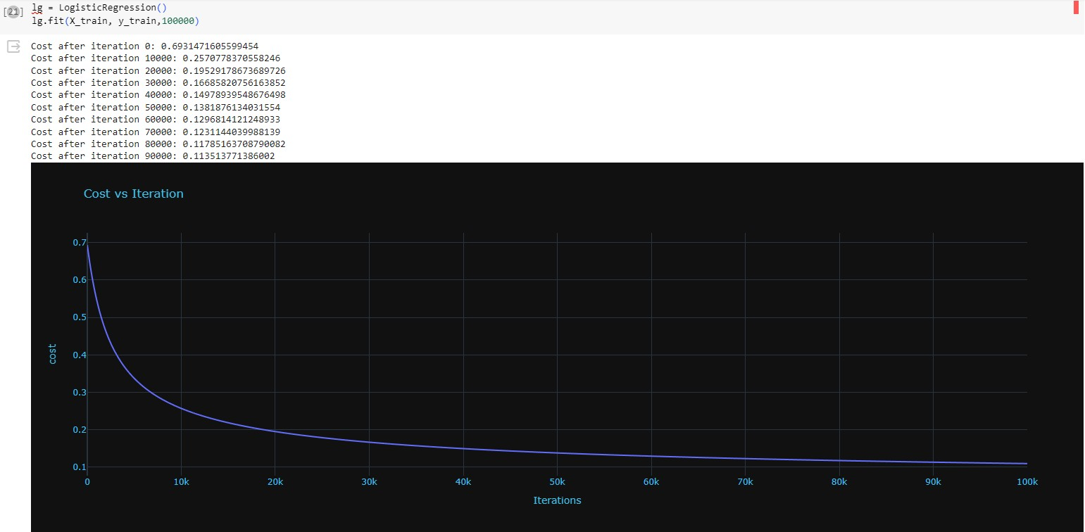

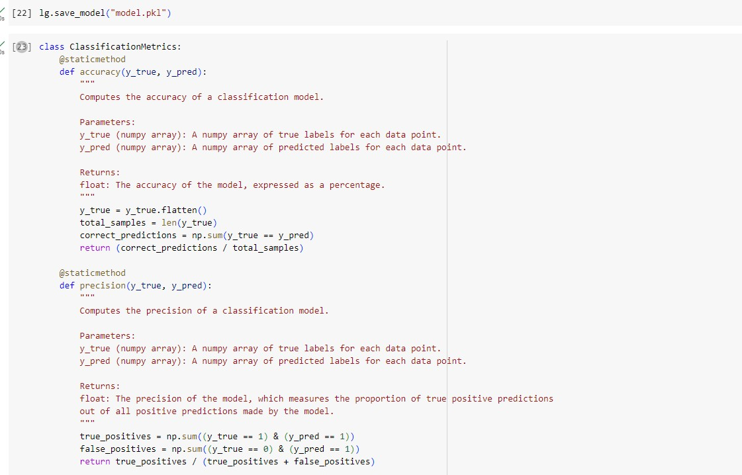

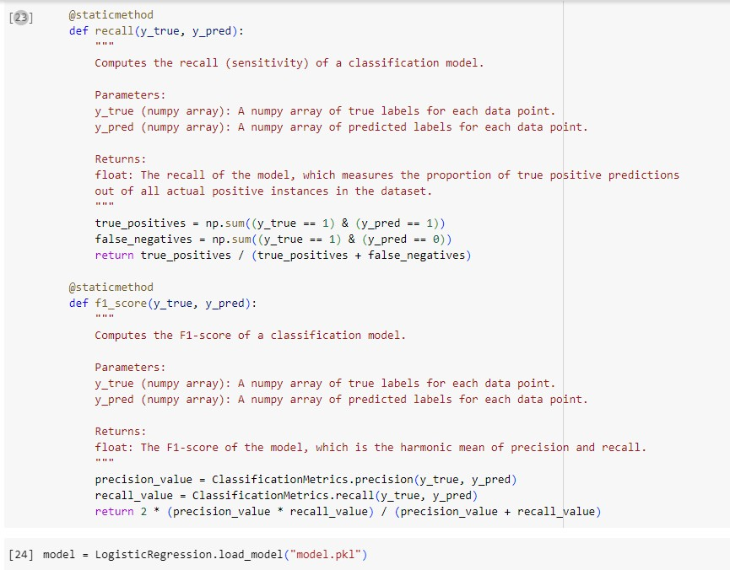

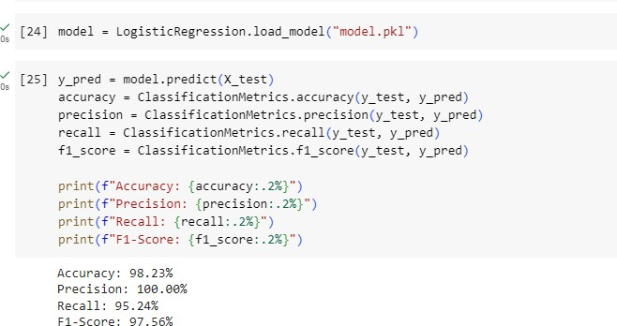

# 24.05.2024

Build support vector machine for the dataset: Snapshot:

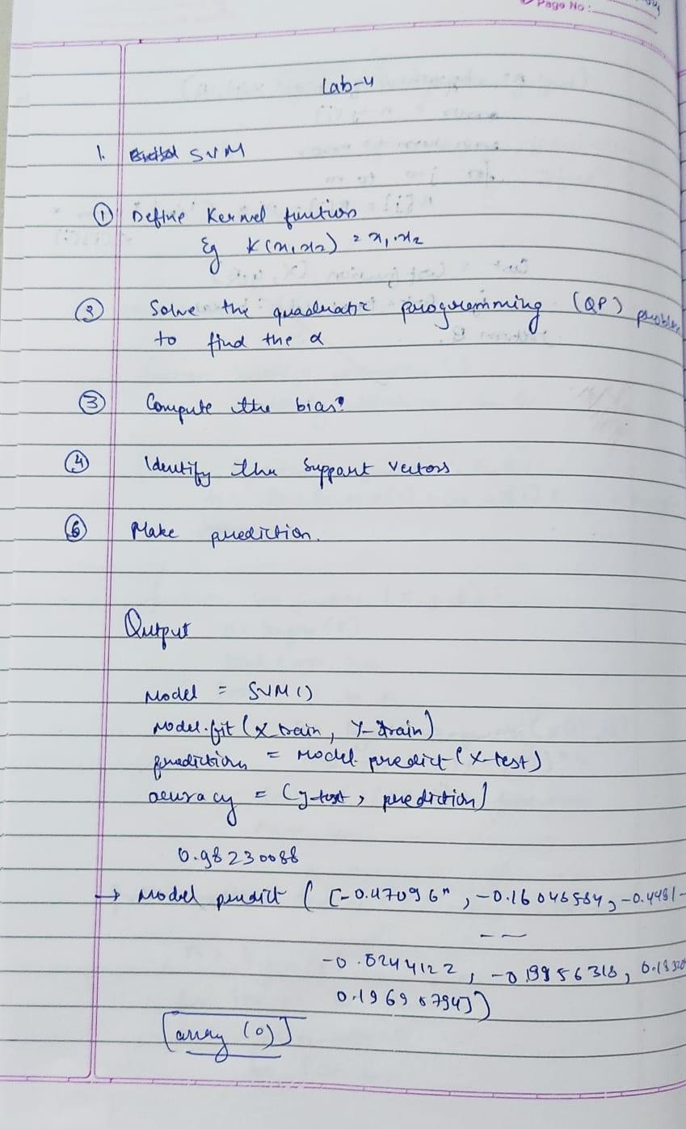

Code:

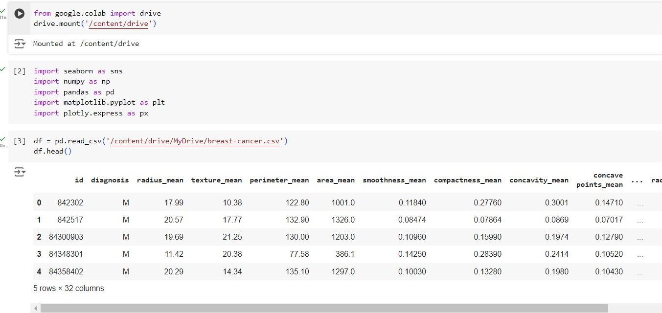

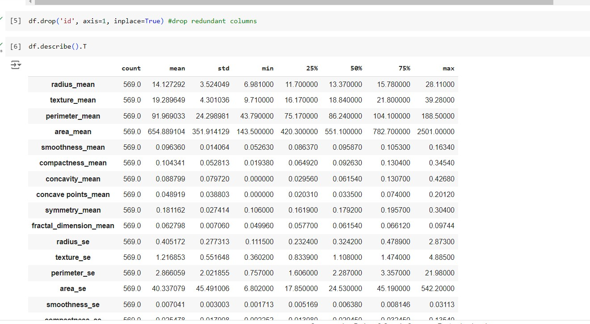

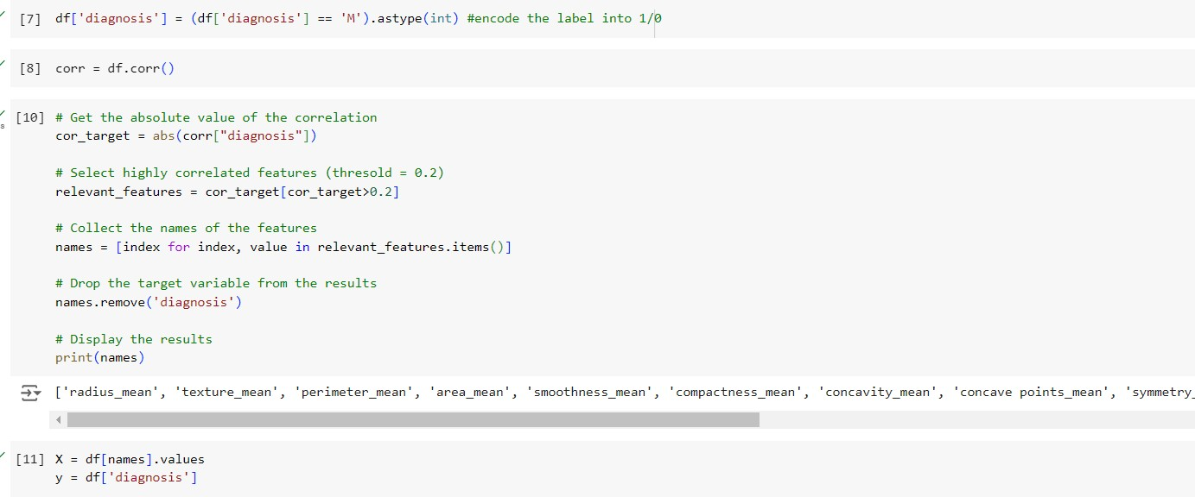

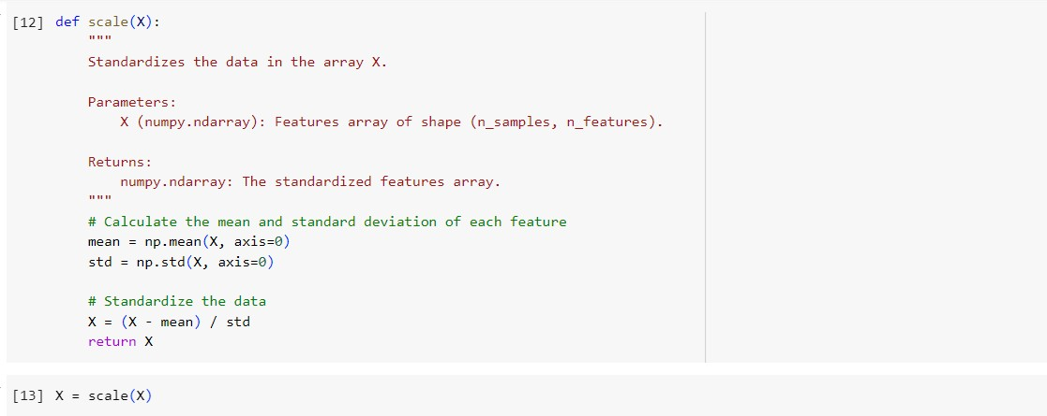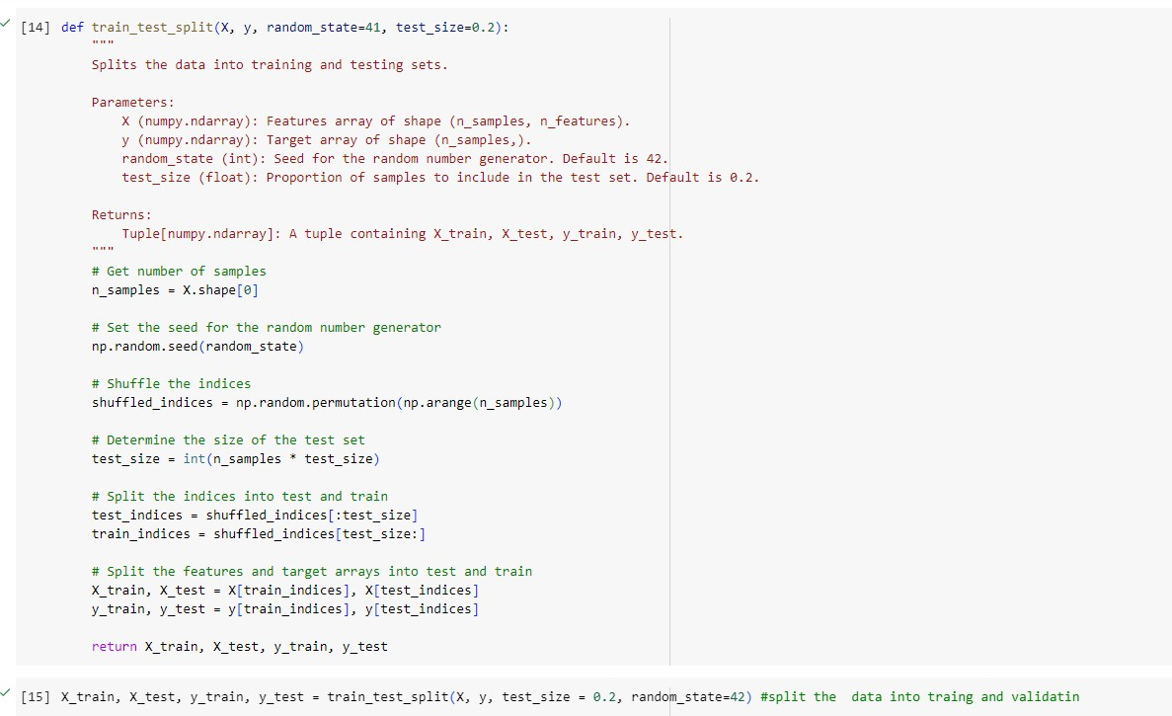

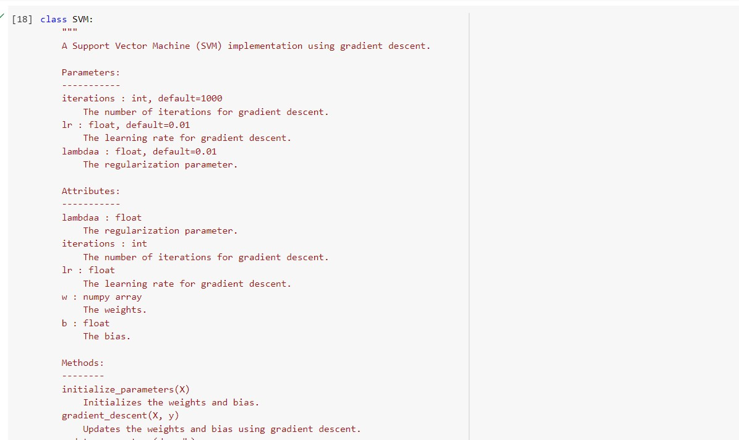

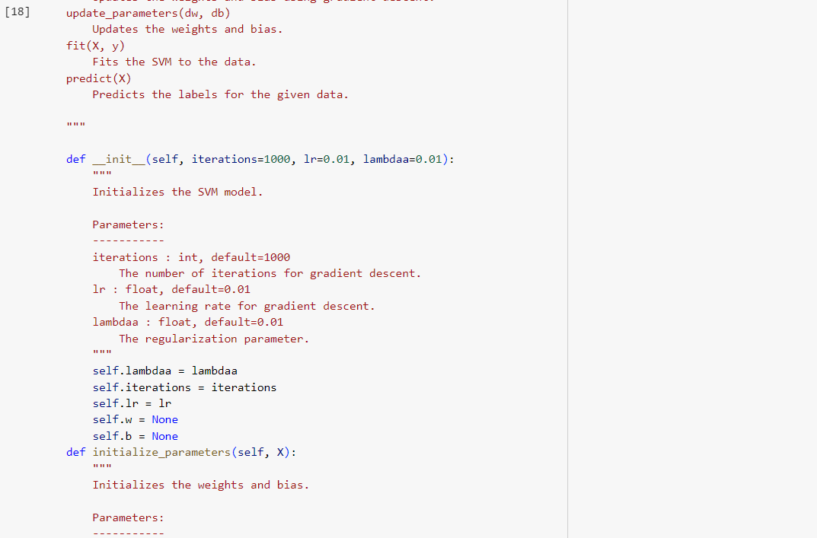

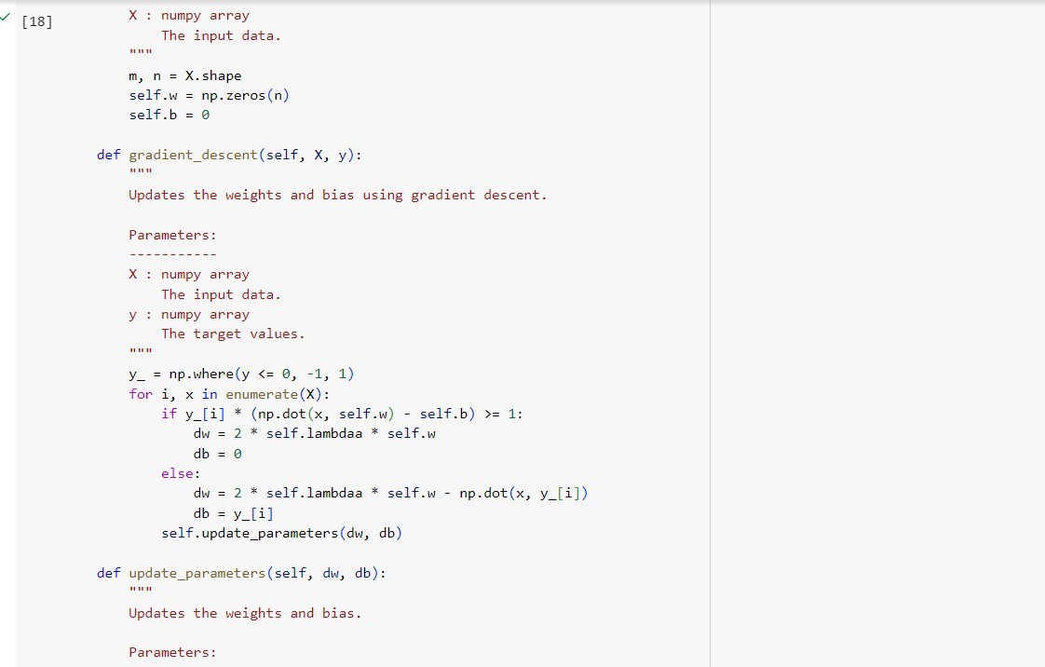

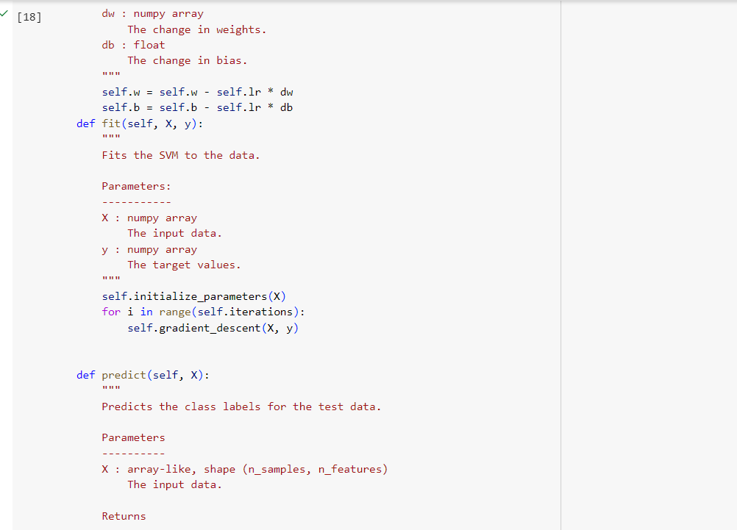

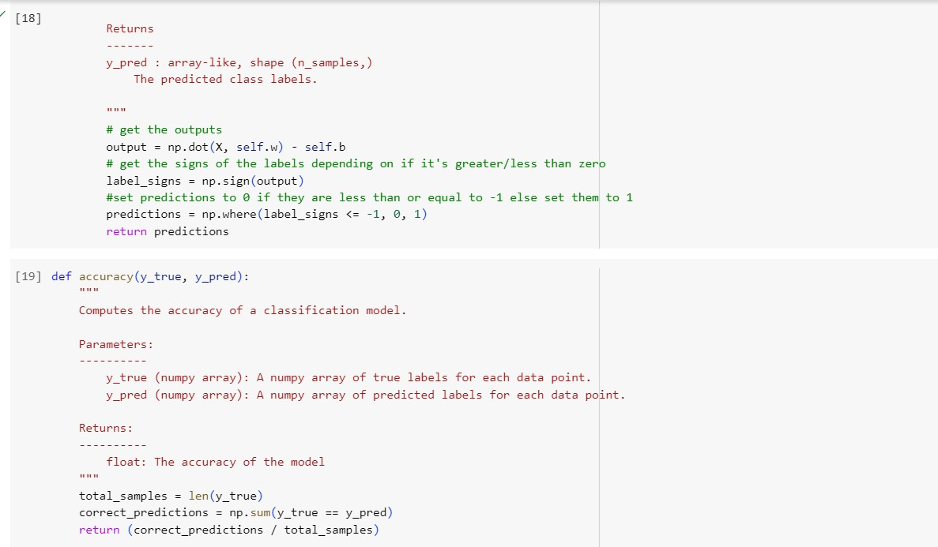

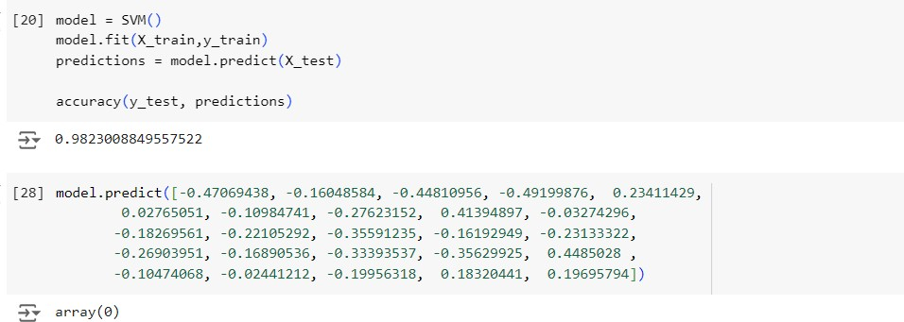

# 24.05.2024

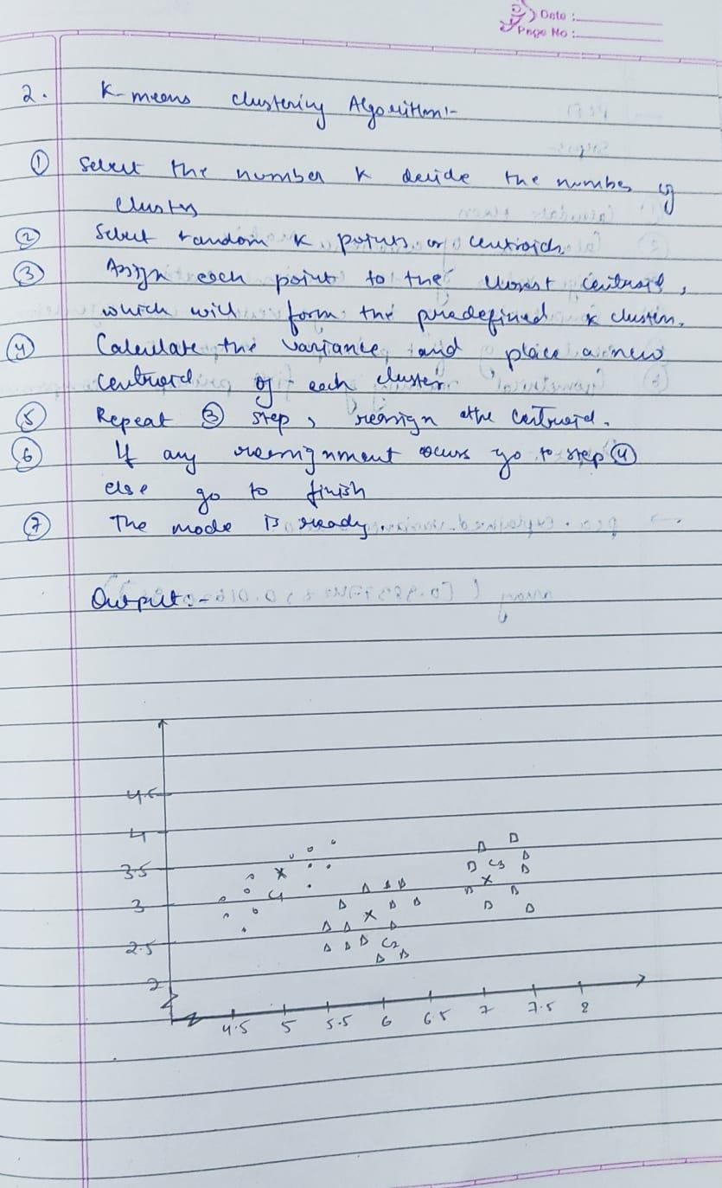Build k-means algorithm to cluster a set of data stored in a .CSV file. Snapshot:

Code:

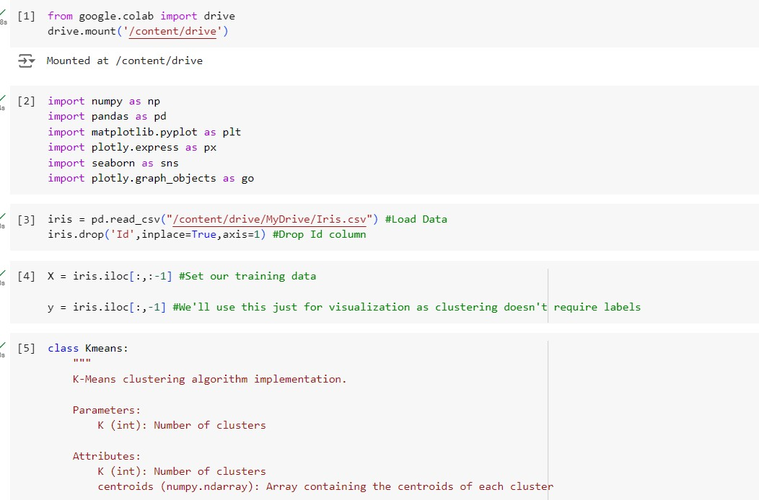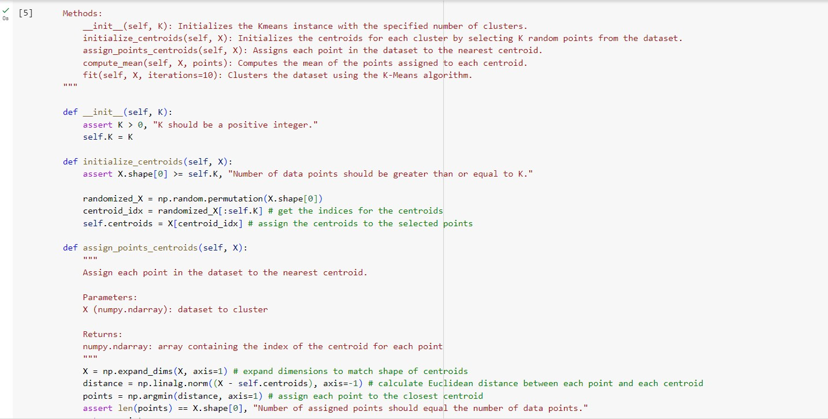

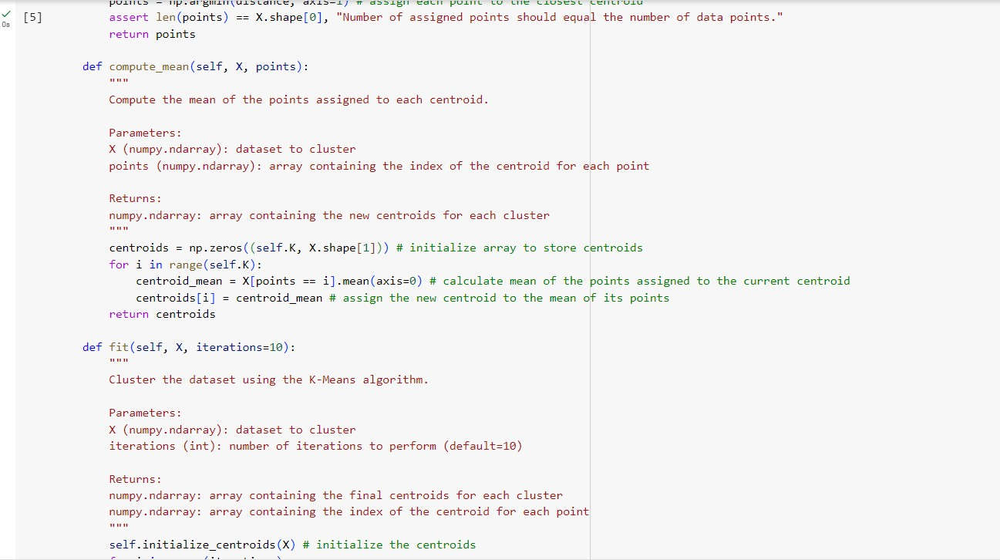

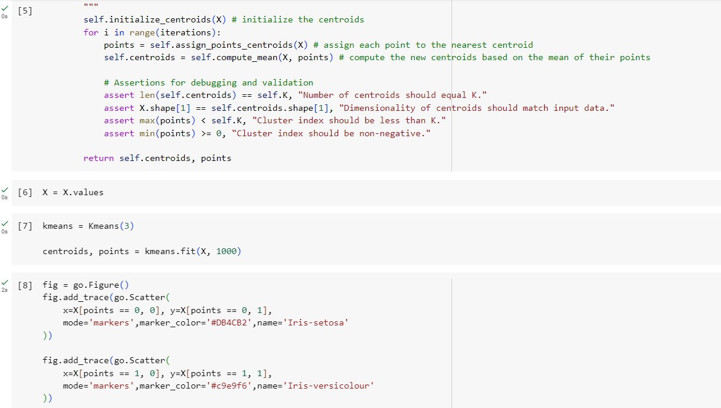

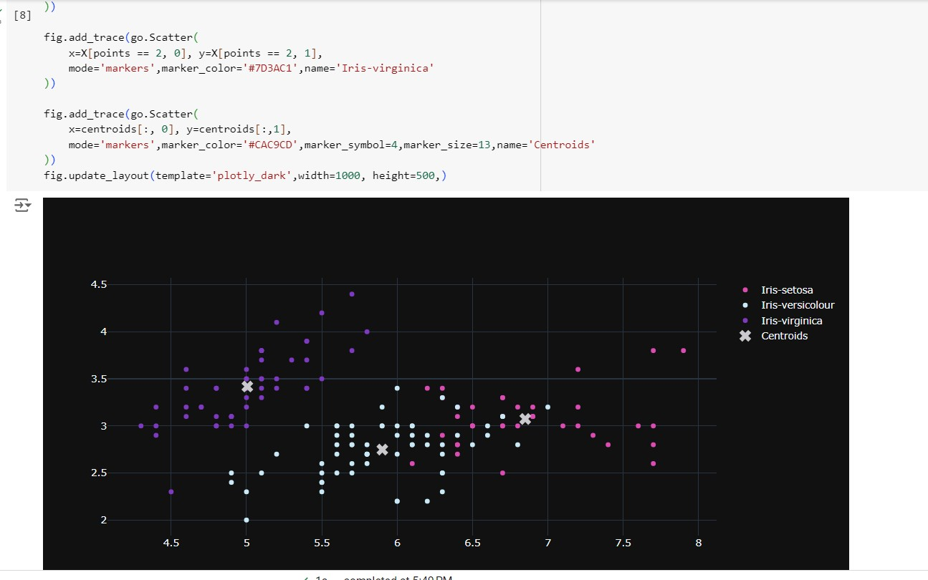

# 24.05.2024

Implement dimensionality reduction using principle component analysis (PCA).

Snapshot:

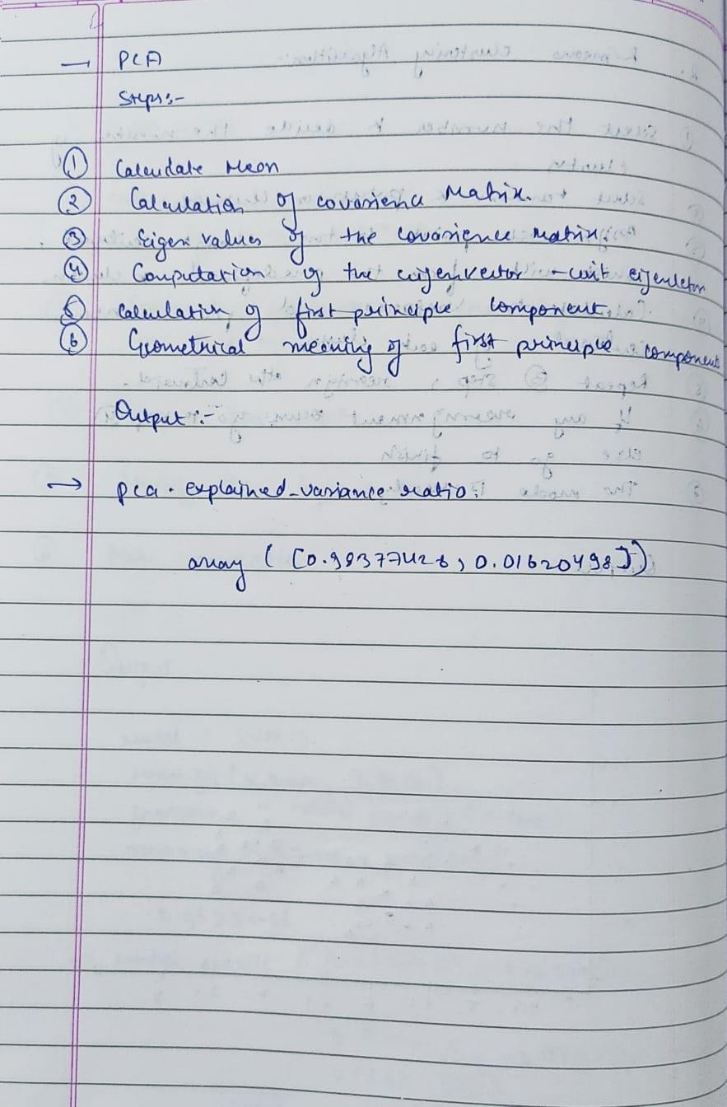

Code:

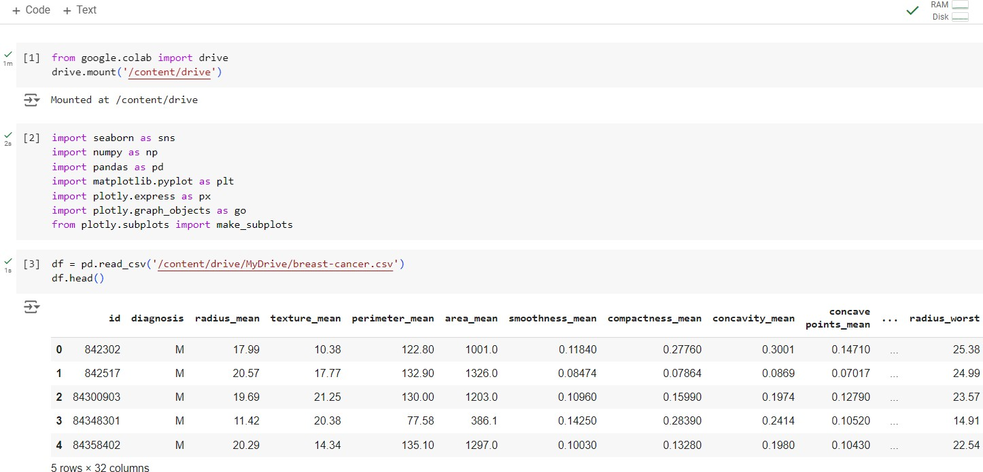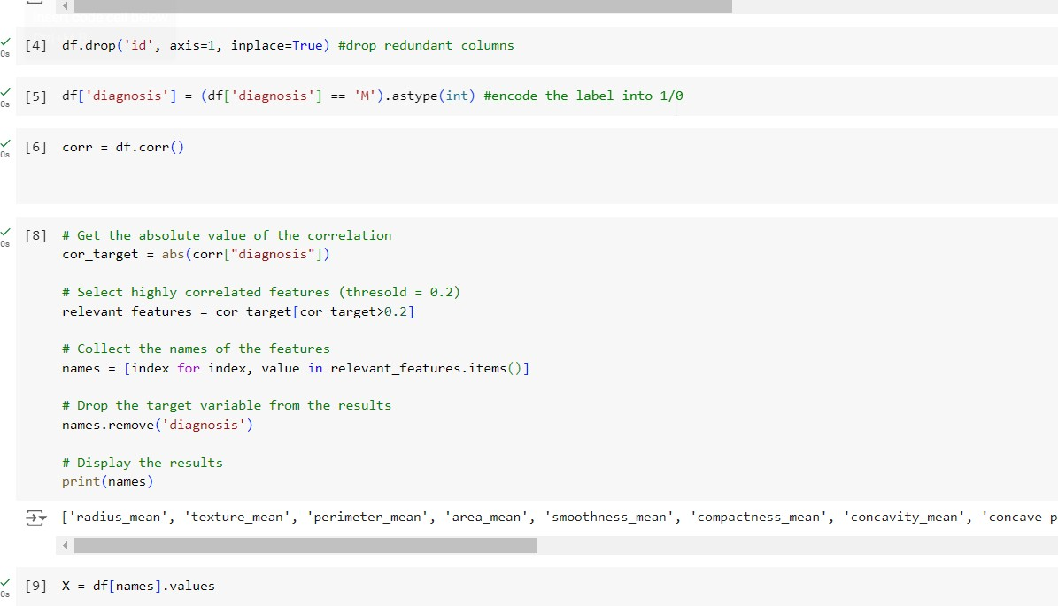

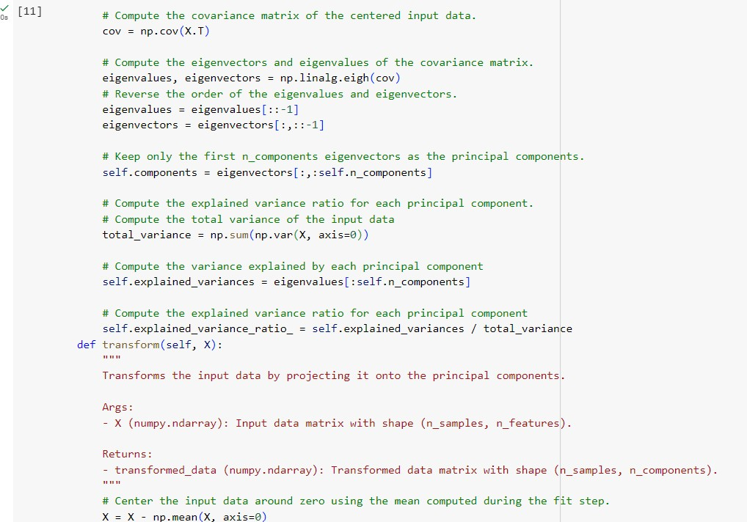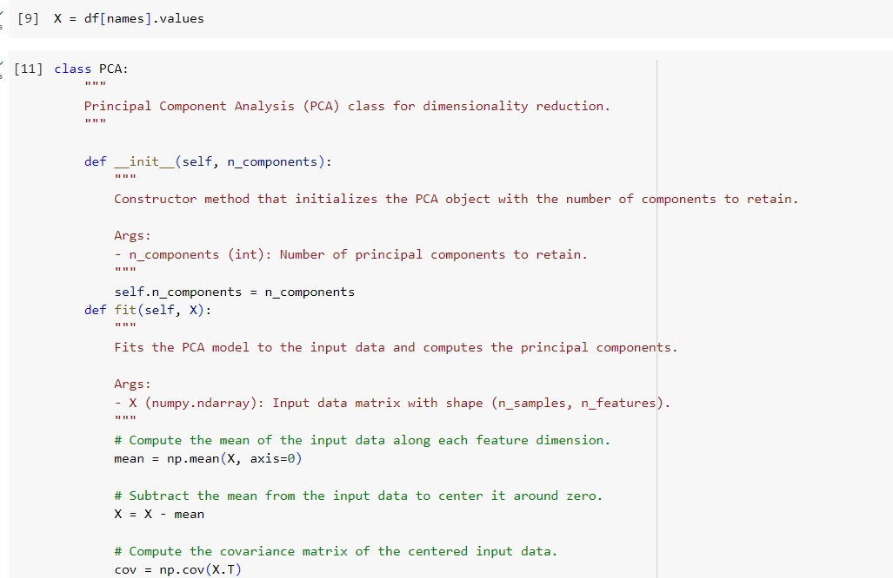

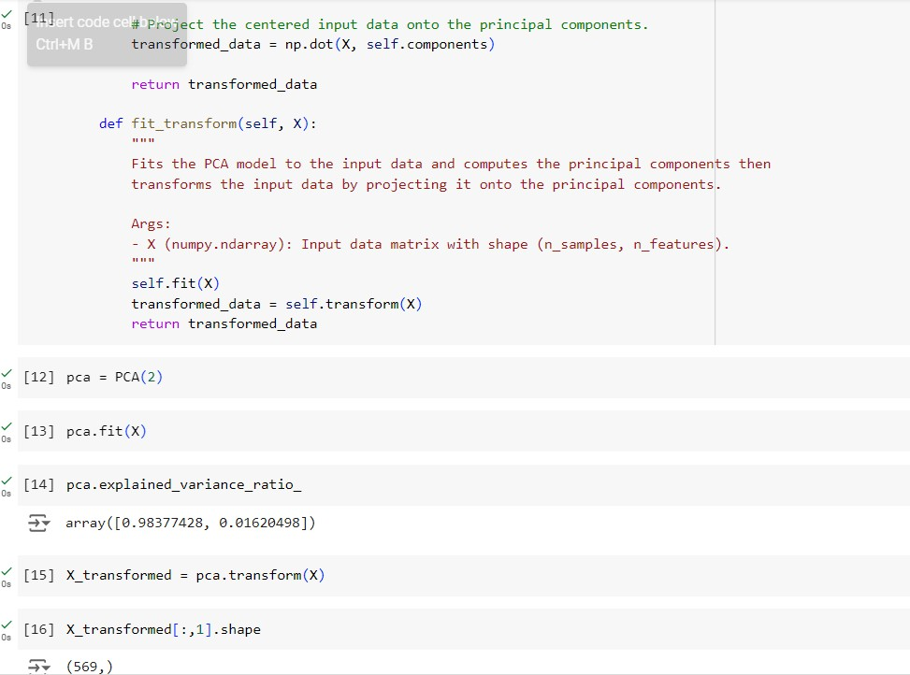

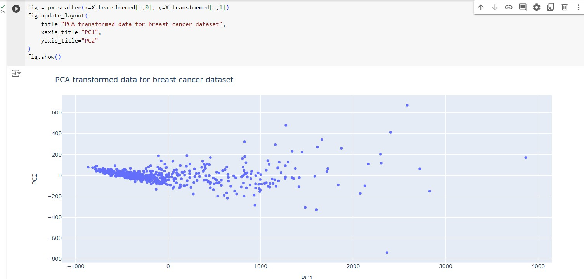

# 31.05.2024

Build Artificial Neural Network model with back propagation on a given dataset

# Snapshot:

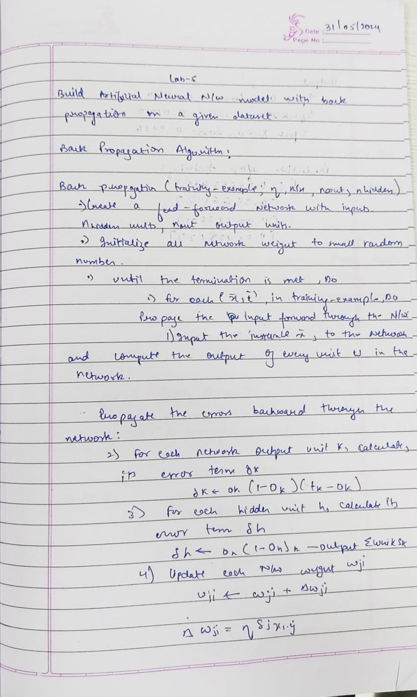

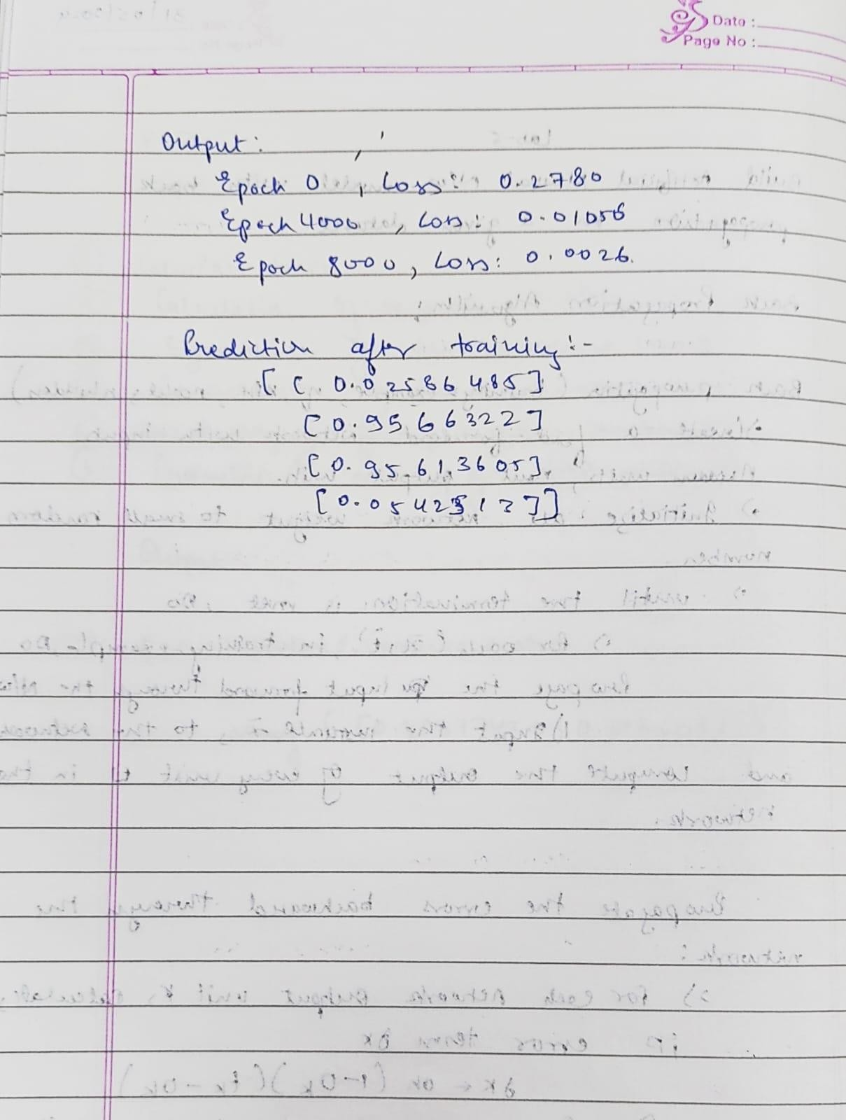

**Code:**

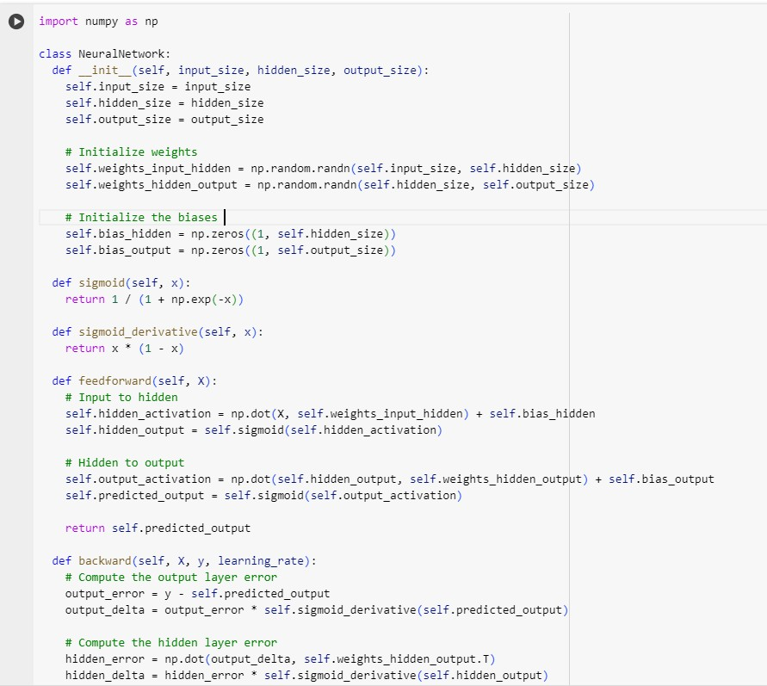

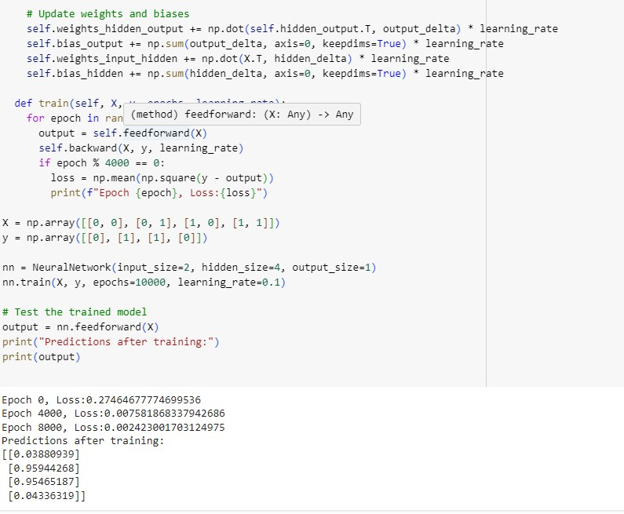

31.05.2024

2.a) Implement Random Forest ensemble method on a given dataset.

Screenshot:

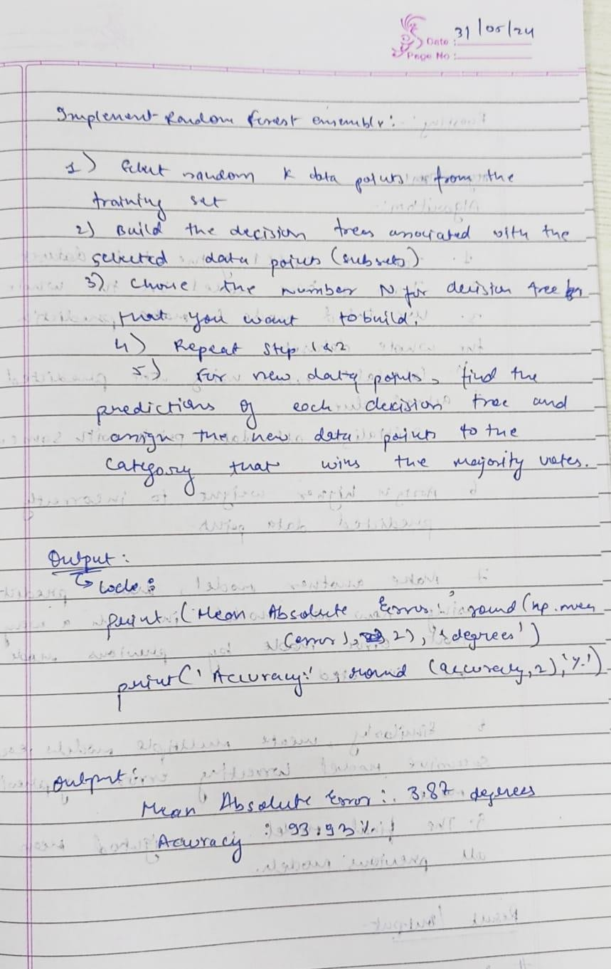

Code:

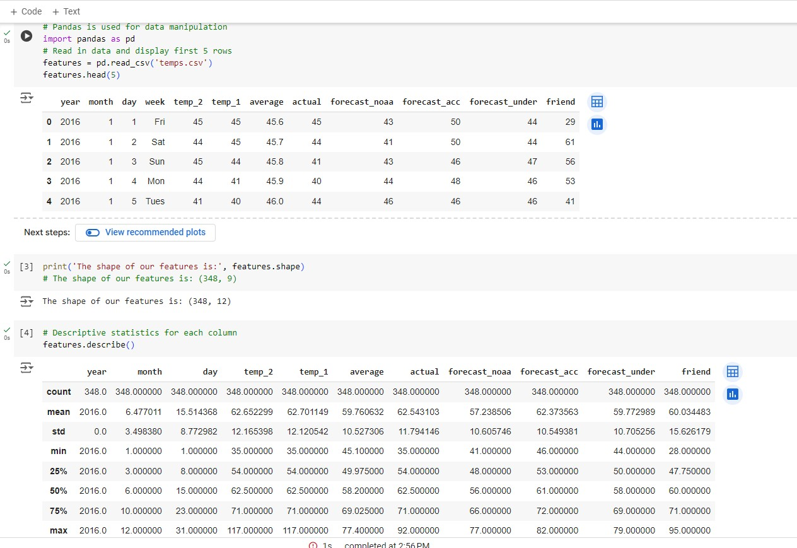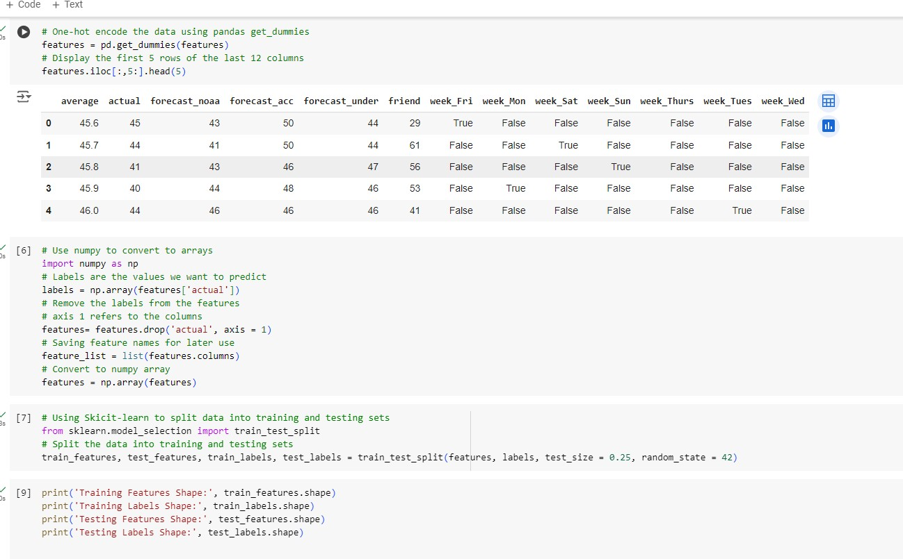

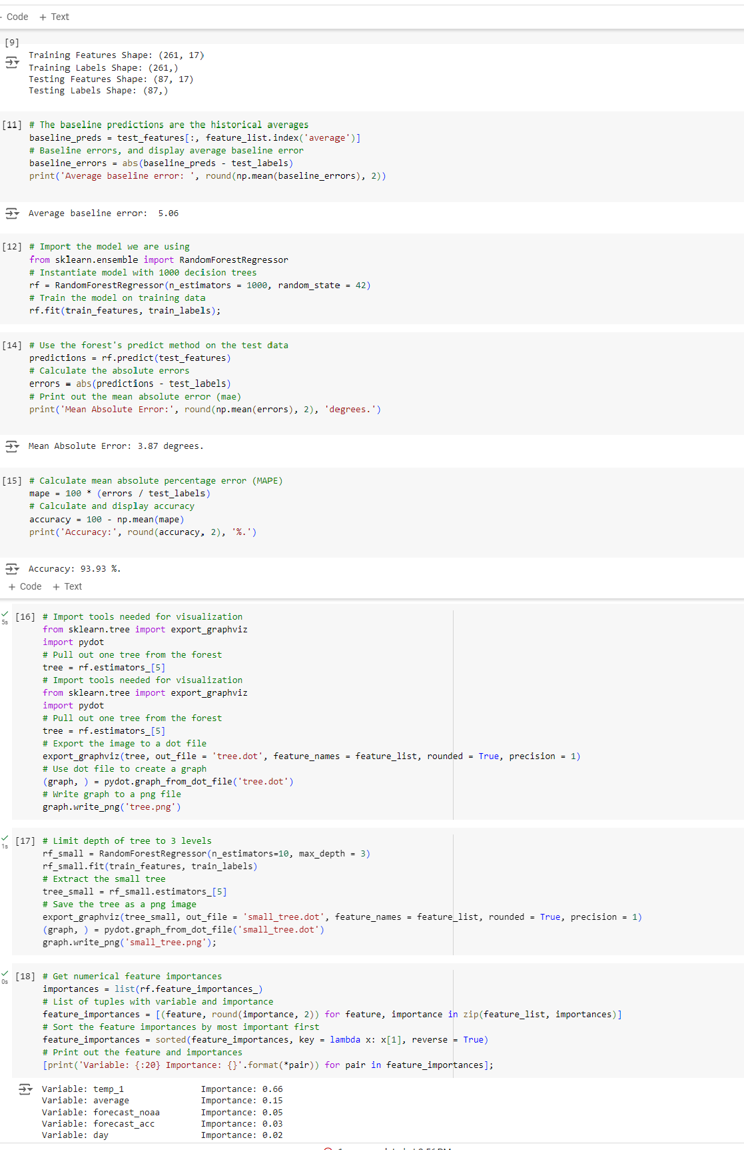

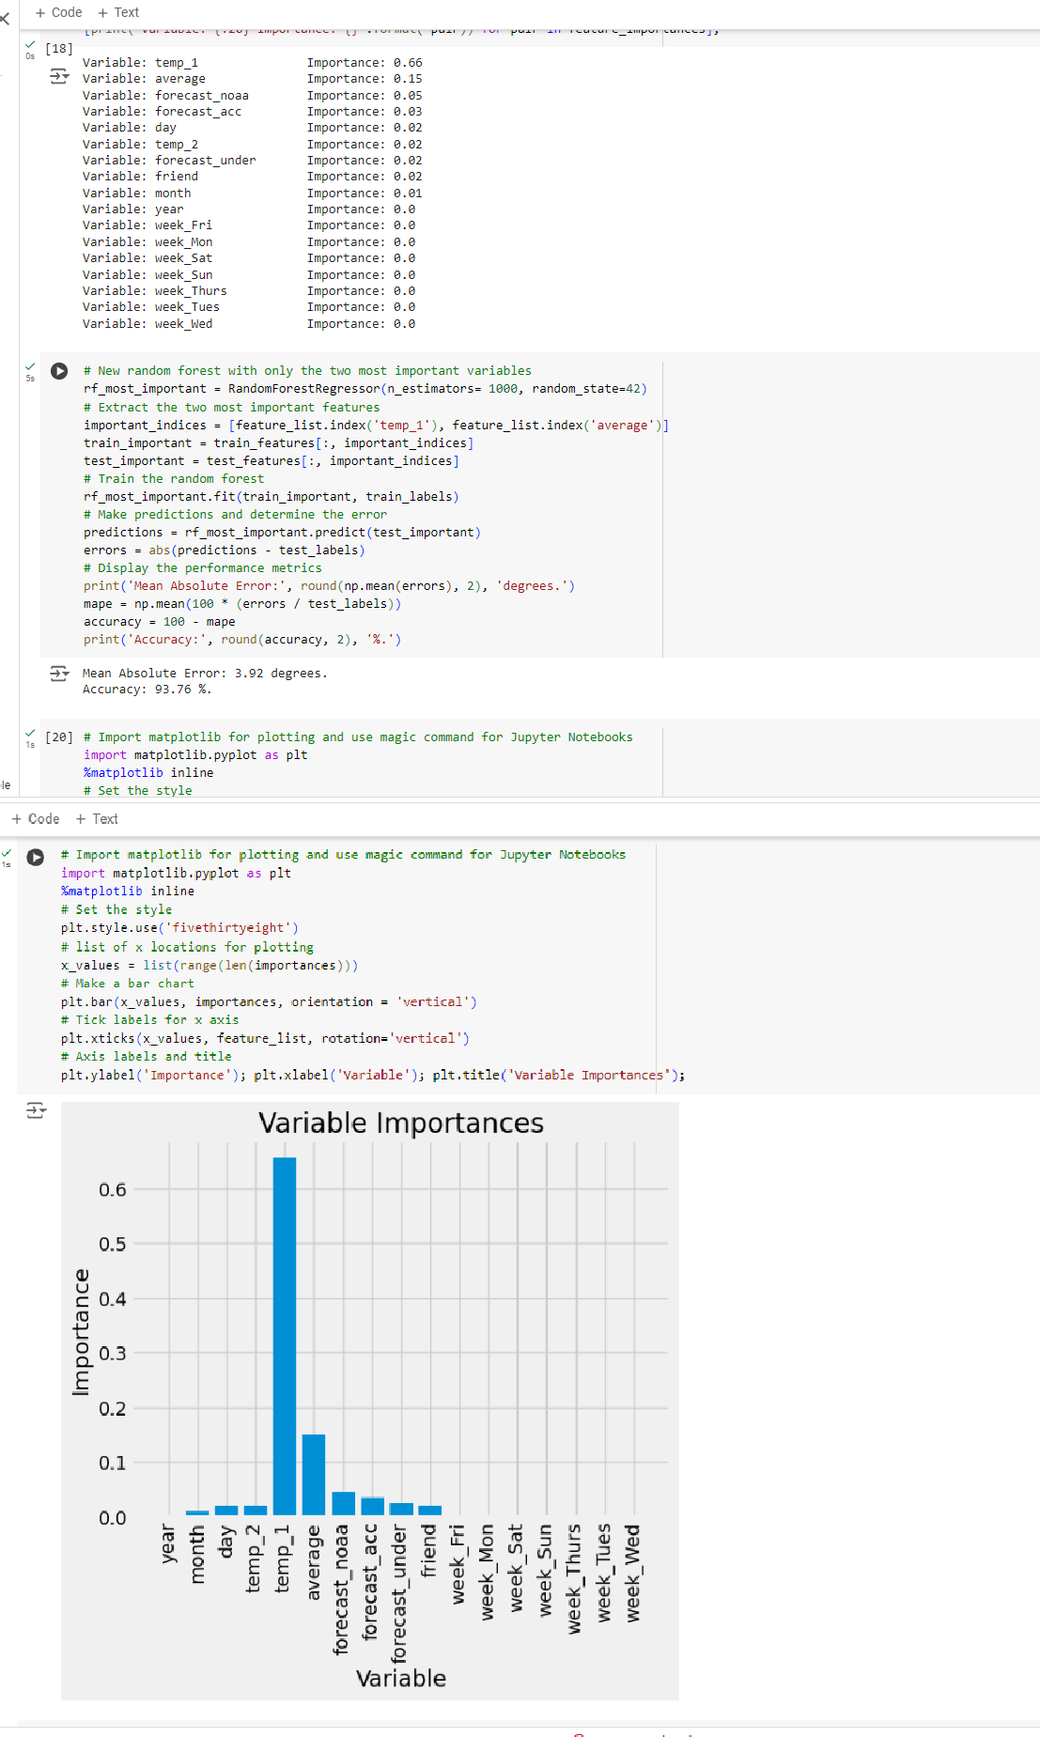

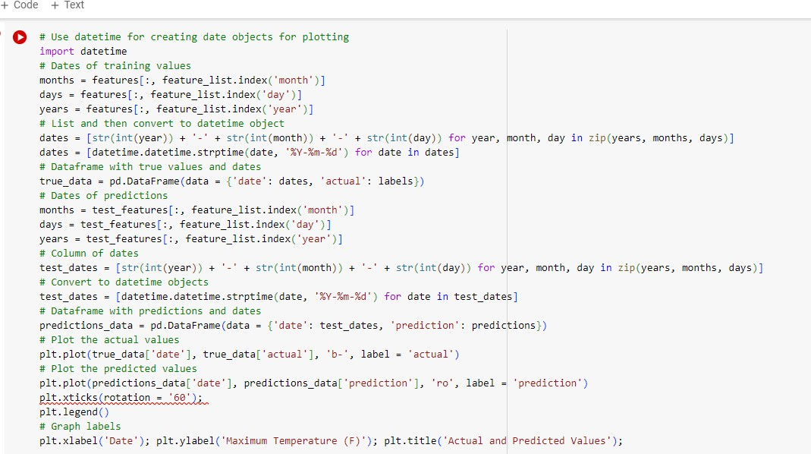

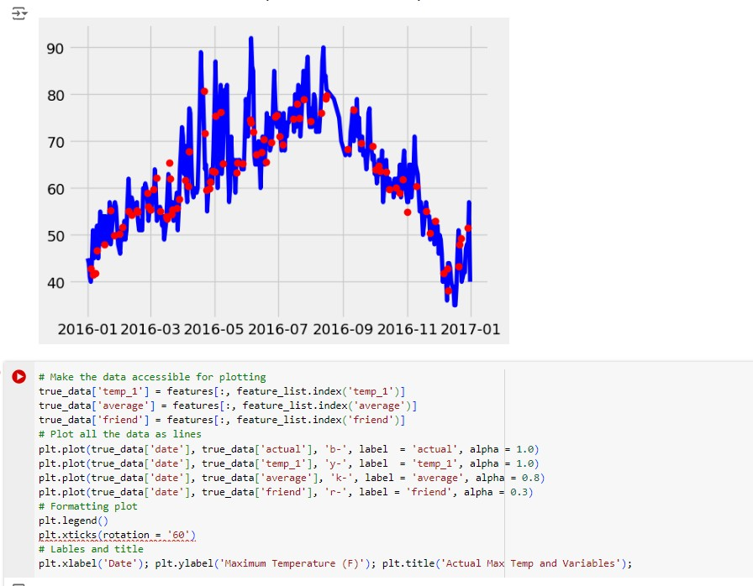

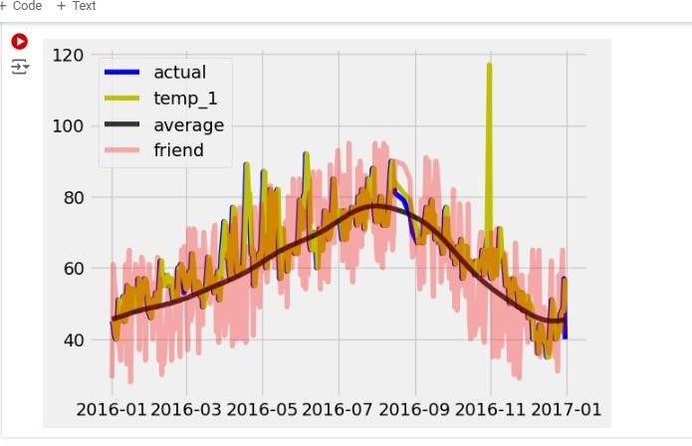

31.05.2024

b) Implement Boosting ensemble method on a given dataset

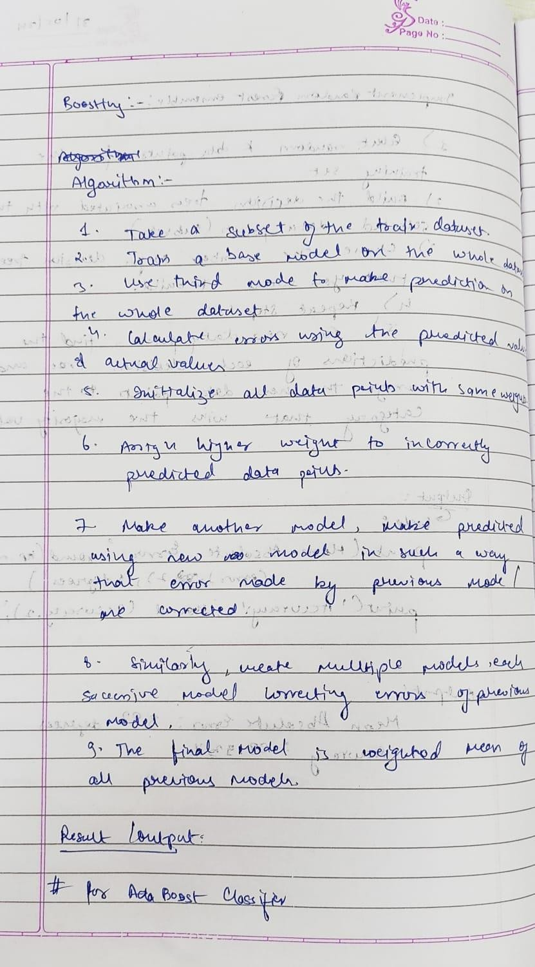Screenshot:

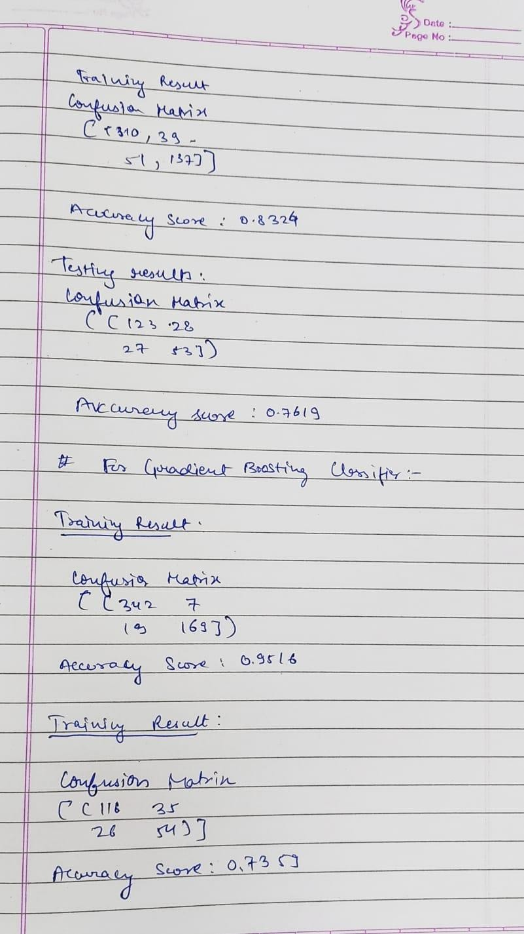

Code:

